Master project:
“Mapping crustal thickness using satellite gravity gradient data”
The master student will work with recently acquired (2009-2014) GOCE – satellite gravity gradient data. The project will include processing, modelling, and data interpretation with a focus on mapping of the Earth crustal thickness distribution. The student will work on implementation of forward and inverse modelling of gravity and gravity gradient data in spherical coordinates. It is expected that the master student is motivated/enjoy MATLAB/Python programming.

GOCE
https://earth.esa.int/web/guest/missions/esa-operational-eo-missions/goce
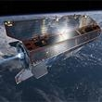
ESA's dart-like Gravity field and Ocean Circulation Explorer (GOCE) Earth Explorer orbits as close to Earth as possible - just 260 km up - to maximise its sensitivity to variations in Earth's gravity field.
Launched in 2009, GOCE's state-of-the-art gradiometer is mapping Earth's geoid to an unprecedented level of accuracy, opening a window into Earth's interior structure as well as the currents circulating within the depths of it's oceans.
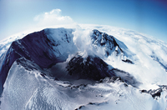
Since the gravity measurements taken by GOCE reflect density variations in the Earth's interior, the resulting data will lead to new insights into processes occurring in the lithosphere and upper mantle - down to a depth of about 200 km. This detailed mapping along with seismic data is expected to shed new light on the processes causing earthquakes and volcanic activity and potentially lead to an improvement in the prediction of such events.
GOCE will also further our knowledge of land uplift due to post-glacial rebound. This process describes how the Earth's crust is rising a few centimetres in Scandinavia and Canada as it has been relieved of the weight of thick ice sheets since the last Ice Age - when the heavy load caused the crust to depress. As a result, there is global redistribution of water in the oceans. Hence, a better understanding of these processes help in assessing the potential dangers of current sea-level change.
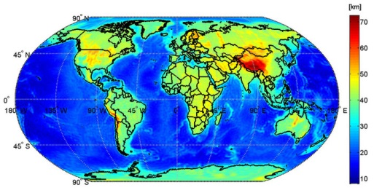
This map shows the global Mohorovičić discontinuity – known as Moho – based on data from the GOCE satellite. Moho is the boundary between the crust and the mantle, ranging from about 70 km in depth in mountainous areas, like the Himalayas, to 10 km beneath the ocean floor.

