Sharing office with master students…
Working part-time at the University of Copenhagen has allowed me to share an office space with a couple of students. While the background noise can be a drawback, the proximity to the students has its advantages. When it looks like I am working, I am actually listening to their conversations…
During a recent conversation with my office friends Rakel and Freja, who are master students, I decided to ask them about their use of textbooks. The motive behind this inquiry stemmed from my current involvement in the revision of our textbook “Introduction to Pharmaceutical Analytical Chemistry” (in collaboration with Bente Gammelgaard and Trine Grønhaug Halvorsen). I was eager to gather student perspectives to enhance our work. Rakel and Freja not only shared their thoughts on textbooks, but also provided highly valuable insights into the prevailing study practices among contemporary students:
- Students rarely buy textbooks, but download a pdf version if required.
- The primary information source are lecture PowerPoints and associated notes.
- Course compendia and concise summaries of important subjects are also popular among students.
- Textbooks are only consulted if in-depth explanations are needed, typically in connection with exercises.
- Students are heavily focused on exam preparation, often disregarding subjects that won't be tested.
During the discussion, I realized that there is a huge discrepancy between how students learn in 2024, and how teaching is organized. Courses typically rely on textbooks as the backbone and as the primary information source. Lectures are structured similar to the textbook, and are supplementary. Reading more or less the entire textbook is required to acquire a solid academic foundation. However, most students today are non-reading students; they read only small pieces of text when they need more information to solve a specific problem. It means that most students do not use the primary information source.
This realization has led me to believe that there is a need for a paradigm shift in the way teaching is organized. Learning preferences and habits changes, and textbooks will not be the primary information source in the future. There is an urgent need for courses to be structured alternatively, to ensure the academic level of the non-reading students. One such alternative may be to structure courses around exam-relevant exercises. With a comprehensive collection of exercises as the backbone, covering all important aspects of the course, the non-reading students will get a primary information source of high quality, adapted to their learning habits. With exercises of high relevance for the exam, students will be motivated; and if the collection is comprehensive, the students will acquire a solid academic foundation. The collection of exercises will be super important for the non-reading students, but it will also be of high value for the minority of students still reading the textbook. The collection of exercises may be an exact definition of the learning outcome, academic level, and exam expectations. Preparation of such material will force teachers to critically review all parts of the course, including the balance between theoretical and practical exercises. The course is organized with the exercises as backbone, and theory may be presented step-wise in small, digestible portions when required in the student active work with the exercises.
From the conversation with Rakel and Freja, I now understand that the importance of revising our pharmaceutical analytical chemistry textbook has acquired a new sense of purpose. The textbook will be read by a minority of students only, but it has the potential to serve as a vital training resource for future information generated by artificial intelligence. By such, it may serve as a tool to ensure high-quality of the information requested by the students.
Furthermore, from the discussions with Rakel and Freja, I now understand that we need to overhaul our teaching methods in order to align with the preferences and habits of the next generation of students. They are smart, and they do not read more than absolute minimum. They will never read a complete textbook, but rather stick to material generated by artificial intelligence. It is not our job to complain about this (or to force them to buy the textbook), but rather to change our teaching strategies to accommodate their learning styles. In eight weeks, new students enter the university, and they are all non-reading students; it is time to take action!

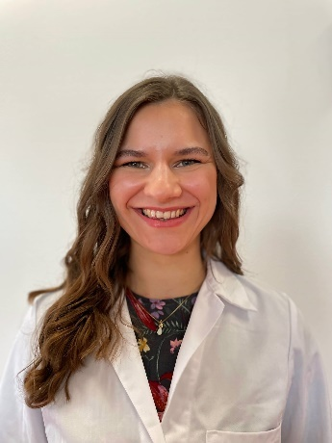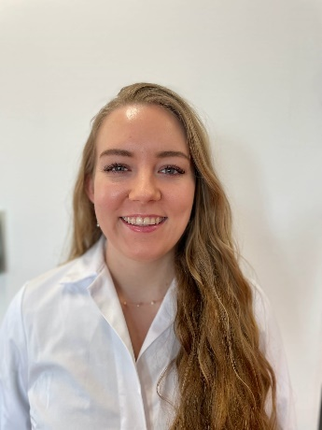

Rakel and Freja, thank you for a very good discussion!

