
Key results from Norway – Darwin EU® P4-C1-016
Annual seasonal influenza vaccine effectiveness

Generating robust real-world evidence on influenza vaccine effectiveness (IVE) has become a priority at the European Medicines Agency. This DARWIN EU® study aimed to assess the availability, quality, and completeness of seasonal influenza-related information to inform potential future IVE studies.

Study overview
Design: Population-level cohort study using data sources from Croatia, Denmark, Finland, Norway, Spain, and the UK.
Population: 5.55 million individuals from Norway, 2018-2023.
Exposure: Influenza vaccination (ATC: J07BB).
Outcomes: Influenza-like illness (ILI), acute respiratory infection (ARI), severe acute respiratory infection (SARI), and all-cause and respiratory/influenza-related hospitalization and mortality.

Influenza vaccine uptake in Norway
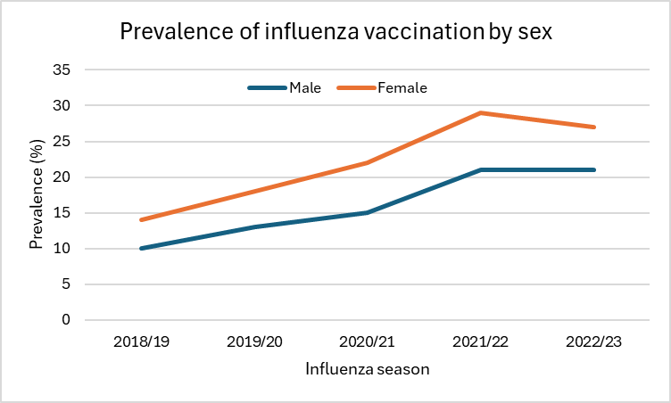
- Adults ≥65 years consistency showed the highest prevalence of influenza vaccination (38-64%). Norway had the lowest level of vaccination among children <6 years (<1.5%).
- Hypertension (40-45%), cardiac conditions (37-41%), diabetes mellitus (13-15%), asthma (18-20%), and cancer (22-24%) were the most common comorbidities.
Norway-specific results
- ARI was the most frequently observed outcome with incidence rates ranging between 11,467 and 14,931 per 100,000 person-years (PY).
- Influenza exceeded 1,000 cases per 100,000 PY in some seasons, rates of other outcomes remained below 1,000 per 100,000 PY.
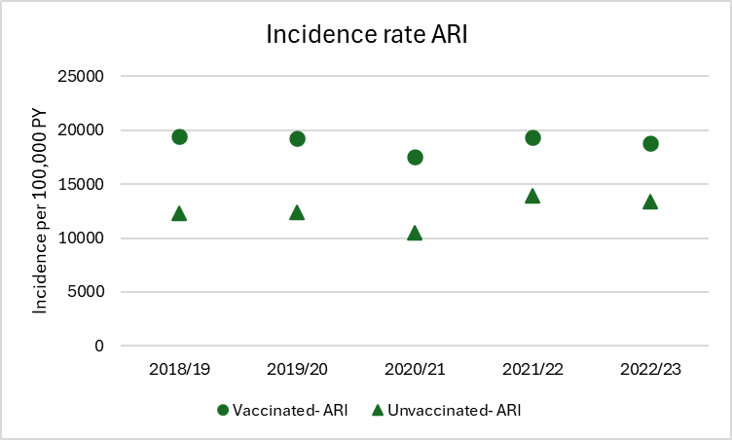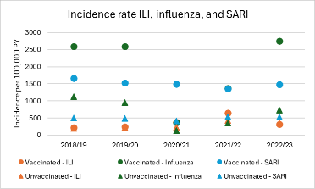
- Incidence rates for all-cause hospitalization and death remained relatively stable over time.
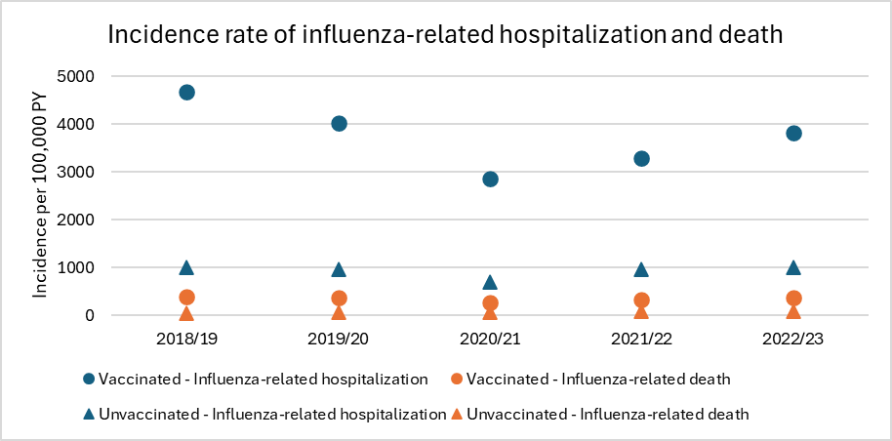

Data & Methods notes
- The higher absolute incidence rates for several outcomes in the vaccinated group likely reflect their older age and higher burden of chronic conditions, consistent with national recommendations to vaccinate at-risk groups.
- No information on influenza vaccine brands and administration routes was available in the Norwegian data, which may limit the ability to contribute to future IVE studies.

How was this useful?
Norway was among the countries with lowest influenza vaccination prevalence, being 15% in the influenza season before the COVID-pandemic, and sharply increasing during the 2020/21 season. Influenza vaccination prevalence slightly decreased after this peak. Vaccine recipients were predominantly older adults and female, with comorbidities consistent with the targeted risk groups. Incidence rates of respiratory outcomes were generally stable over time, except for a notable drop during the COVID-19 pandemic in 2020/21. Continued refinement and validation of influenza-related outcomes may enhance the ability of these data sources, including Norwegian linked health registry data, to contribute reliable and policy-relevant IVE evidence.

Access to the full report
DARWIN EU® Proof-of-concept: Preparedness for annual seasonal IVE studies - Vaccine coverage and incidence of influenza-related outcomes
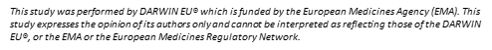
Contact
Hedvig Nordeng:

h.m.e.nordeng@farmasi.uio.no

