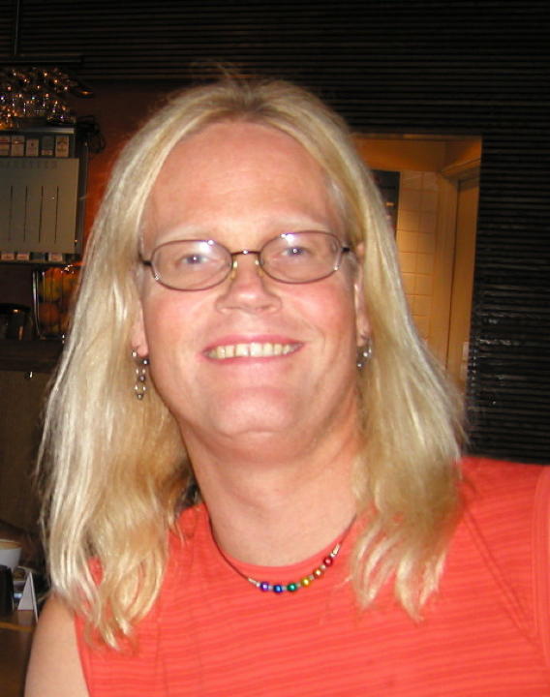
Curriculum vitae with track record

Name: Arild Christian Rustan
Date of Birth: 9. March 1957
Degrees: MSc Pharm, D Phil (PhD)
Sex: Non-binary
Nationality: Norwegian
Researcher ID: Scopus: 35562537200

EDUCATION
1981 Master of Science (Pharmacy), University of Oslo
1988 Doctor of Philosophy (Pharmacology), The Faculty of Mathematics and Natural Sciences, University of Oslo

CURRENT AND PREVIOUS POSITIONS
  - Research Assistant, Dept. of Pharmacology, School of Pharmacy, University of Oslo
  - Post-doctoral Research Assistant, Institute for Nutrition Research, University of Oslo
  - Associate Professor, Dept. of Pharmacology, School of Pharmacy, University of Oslo
- Professor (pharmacology, pharmacodynamic), Section for Pharmacology and Pharmaceutical Biosciences, Department of Pharmacy, University of Oslo

MOBILITY
1999-2000: L. Storlien, Dept. of Biomedical Science, University of Wollongong, NSW 2522, Australia. This research stay has initiated collaboration with AstraZeneca, Mølndal, Sweden. Autumn 2008 and summer 2009: SR Smith, C Moro and S Bajpeyi, Pennington Biomedical Research Center (PBRC), Baton Rouge, LA, USA.
Autumn 2015: P. Flachs, J Kopecky, Institute of Physiology Academy of Sciences of the Czech Republic, Prague, Czech Republic.
Spring 2016: C. Moro, Institut de Médecine Moléculaire, INSERM U858, Toulouse, France.

SUPERVISION OF GRADUATE STUDENTS AND RESEARCH FELLOWS
Doctoral fellows (PhD): Trine Ranheim, Ane Gedde Dahl, Eili Tranheim Kase, Nina Pettersen Hessvik, Natasa Nikolic, Siril Skaret Bakke, Yuan Zeng Feng, Jenny Lund, Nils Gunnar Løvsletten
At present: Abel Mulu Mengeste, Christine Skagen, Nimo Osoble, Stanislava Sevanovic.
I have also been co-supervisor for the following doctoral fellows: Steinar Skrede (1994), Jon
Skorve (1994), Quy N. Diep (1996), Bente E. Halvorsen (1996), Livar Frøyland (1996), Nina
Willumsen (1997), Hege Vaagenes (1997), Lise Madsen (1998), David Fraser (2000),
Merethe H. Rokling-Andersen (2009), Andreas J. Wensaas (2010).
Master students at School of Pharmacy, at least 25 internal students since 1991.
I have also been internal supervisor at School of Pharmacy (ca. 45 students since 1991).
Erasmus (European) students: David Fraser, Aberdeen, Scotland, UK (1994); Chiara
Martinelli, Pavia, Italy (1995); Linda van den Bosch, Wageningen, The Netherlands (1995);
Martijn van der Gaag, Wageningen, The Netherlands (1995); Sigrid Brouwer, Wageningen,
The Netherlands (1996); Audrey Dorthu, Liege, Belgium (2005).
University of Wollongong, Australia 2000: Dept. of Biomedical Science: BMS 302:
Research Topics in Metabolism: Cassandra Haley, Kelly Newell and Karyn Parsons.

TEACHING ACTIVITIES
At present my main teaching activity is in the Master program in Pharmacy, University of Oslo: Physiology, basic pharmacology, pharmacotherapy, clinical pharmacy. PhD program: Advanced pharmacology and pharmacotherapy.

COMMISSIONS OF TRUST
I have been committee member for Norwegian Research Council (FRIBIO) and served on several international evaluation panels (i.e. EU-COST actions, Research, Development and Innovation Council of the Czech Republic, Irish Research Council).
I am regular referee for Diabetologia, Diabetes, J. Lipid Res., PLoS One, Scientific Reports etc.
Have been member of several evaluation committees for PhD candidates in Norway, Sweden, Denmark and Germany.

MEMBERSHIPS OF SCIENTIFIC SOCIETIES
I have been MC member for Norway in COST-actions B5 og B17: "Molecular Mechanisms in the Etiology of Non-Insulin Dependent Diabetes Mellitus", “Insulin resistance, obesity and diabetes mellitus in the elderly” (NRC). Lipgene and Nutrigenomics (NuGo): LipGene was an EU 6th FP IP (2004-2009) entitled "Diet, genomics and the metabolic syndrome: an integrated nutrition, agro-food, social and economic analysis". We were involved in workpackage “Mechanistic studies, human adipocytes and skeletal muscle cells, and animal studies”. NuGo: "Nutrigenomics, a Network of Excellence on Nutrition and Genomics" is a network integrating nutritional genomics in Europe through EU 6th FP. Participating in focus team “Skeletal muscle insulin resistance”.
I have also been MC member of MITOFOOD (COST-action FA0602) (2007-2011), which was a research community for nutritional optimization of mitochondrial function for health promotion and disease resistance.
Collaboration with Jagiellonian University, Krakow and R Blomhoff and RK Berge in Norway within Polish-Norwegian Research Fund (OPI-EAA) (2008-2011): ”The protective mechanisms against neurodegeneration: prosurvival activity of endogenous peptides, L-arginine and fatty acids as potential modulators of mitochondrial function in the stressed brain”. I have been the Norwegian coordinator.
We have participated in an EU project NutriTech in collaboration with Department of Nutrition, UiO:”Application of new technologies and methods in nutrition research – the example of phenotypic flexibility”. (EU 7 large scale integrating project, 2012-2015), workpackage: Muscle and adipose phenotypic flexibility. I have recently been MC representative in MITOEAGLE; “Mitochondrial fitness mapping: Evolution - Age - Gender - Lifestyle – Environment” (EU FP Horizon 2020 COST Action CA15203) (2016 - 2020).

MAJOR COLLABORATIONS
Most important current international collaborations:
- C. Moro, INSERM U858, Toulouse, France.
- S. Bajpeyi, University of Texas at El Paso, El Paso, TX, USA.
- J. Kopecky, Institute of Physiology, CAS, Prague, Czech Republic,
- Victor Zammit, Warwick Medical School, UK,
- Maarit Lehti, Eja Laakkonen, LIKES Research Centre for Physical Activity and Health, Jyväskylä, Finland.
- Matti Jauhiainen, Minerva Foundation Institute for Medical Research, University of Helsinki, Finland
- Hadi Al-Hasani, Margriet Ouwens, Institute for Clinical Biochemistry and Pathobiochemistry, Deutsches Diabetes-Zentrum DDZ. Düsseldorf, Tyskland
- Sergej Pirkmajer, Tomaz Mars, University of Ljubljana, Faculty of Medicine, Ljubljana, Slovenia

Industrial link: We have established collaboration with AstraZeneca (Mølndal, Sweden) regarding cell models and development of new high-throughput methods for measurement of energy metabolism in cells. A new collaboration on innovative drug projects with human skeletal muscle cells as the main cell model has been initiated (2017).

National collaborations (past and present, most important today in bold): Within Faculty: The focus of the MURES group was to study skeletal muscle molecular mechanisms related to insulin resistance and type 2 diabetes mellitus (T2D). The idea of MURES was to integrate pathological human biological material and knowledge from controlled animal experiments and in vitro muscle cell models, with drug design as a final goal.

- Department of Nutrition, School of Medicine, University of Oslo: Fatty acid-induced insulin resistance (LipGene project); muscle metabolic flexibility (NutriTech). Regulation of liver X receptors (LXR) and other nuclear receptors involved in lipid and glucose metabolism. Role of Perilipin2 in skeletal muscle. At present: Knut Tomas Dalen (Perilipins and regulation of lipid metabolism in skeletal muscle cells).
- Core facility for proteomics at the University of Oslo/Oslo University Hospital: Proteomic analysis of secretome from skeletal muscle cells.
- Oslo Metropolitan University (OsloMet) (Vigdis Aas): Molecular and cellular mechanisms for skeletal muscle insulin resistance. Myokines and other secretory factors from skeletal muscle cells.
- The Norwegian School of Sport Sciences: Molecular and cellular mechanisms for skeletal muscle insulin resistance: effects of muscle contraction. Energy metabolism in muscle cells from athletes.
- Dept. of Endocrinology, Oslo University Hospital: Skeletal muscles, myokines and glucose metabolism.
- Institute for Experimental Medical Research, Ullevaal University Hospital, Oslo: Effects of leukaemia inhibitory factor (LIF) on energy metabolism. Regulation of SERCA activity in skeletal muscle.
- Dept. of Clinical Science, University of Bergen (Rolf Berge): Fatty acid-induced insulin resistance (cells and animal studies). Metabolic effects of thio-ether fatty acid analogues. Fatty acid analogues to modify brain function.
- Medicinal Pharmacology and Toxicology, Department of Medical Biology, Faculty of Health Sciences, University of Tromsø: Drug development and moleuclar modeling.
- NorthSea Therapeutics (David Fraser). Modified fatty acids (SEFAs) and fatty liver disease (NAFLD).
- Inland Norway University of Applied Sciences (INN), Lillehammer: Håvard Hamarsland and Stian Ellefsen, intervention study, Alpha and Omega of lifestyle therapy – resistance training and n-3 fatty acids to improve muscle function in obese and lean individuals. Sub-project with human myotubes established from donors from the intervention study: n-3 fatty acids to improve muscle function in obese individuals.
- Proteasegruppen (ProTarg), Farmasøytisk institutt, UiO: Crosstalk between skeletal muscle and bone (New internal collaboration at our section from 2021).

SCIENTIFIC PROFILE
My research has mainly been in the field of lipid and glucose metabolism in various cell culture systems. Together with professor GH Thoresen and ET Kase, I have established a competitive group in the field of skeletal muscle insulin resistance and are involved in several international collaborations and consortia (see above).

Research group: The muscle research group (at Section for Pharmacology and Pharmaceutical Biosciences) is managed by AC Rustan and GH Thoresen (head). The group has long term experience with the study of insulin resistance and fuel metabolism in cultured human skeletal muscle cells (myotubes). We have established a novel high throughput system for measuring fuel-handling processes in cells. This is a non-invasive method for quantifying uptake and oxidation of radiolabeled nutrients like fatty acids, monosaccharides and amino acids (Wensaas et al., J. Lipid Res 2007). Combined with real-time qPCR and genome wide screening, using microarray technology, and specific protein measurements (immunoblotting, enzyme activity assays) this allows us to study functional aspects of gene regulation.
Persons involved are professor V Aas, Oslo Metropolitan University (OsloMet), ET Kase (associate professor), PB Katare, AD Fernandez (scientia fellows), AM Mengeste, C Skagen, N Osoble, S Stevanovic (research fellows), laboratory personnel and master students.
See: https://www.mn.uio.no/farmasi/english/research/groups/muscle-research-group/index.html

In 2008 the research group MURES (Muscle research at MN, http://www.mures.uio.no), leaded by us, have been selected as an Emerging Research Initiative by the Faculty of Mathematics and Natural Sciences (MN), UiO. MURES is a collaboration between the Rustan/Thoresen group and three other research groups at MN.

LXR antagonists innovation project: ”Anti obesity” (NFR-FORNY program 2007-2009; Birkeland Innovation, UiO and Norwegian Research Council (NRC), managed by researcher ET Kase): ”New drugs for treatment of disorders associated with insulin resistance, such as type 2 diabetes and obesity”. Focus is on the LXR antagonist 22-S-hydroxycholesterol (22-S-HC) and derivatives. Stage 2 ”New drugs for treatment of obesity” of this project with focus of low molecular weight derivatives (funded by NRC, 2010-2011). We received Helse Sør-Øst Innovasjonsmidler (2012-2013) to further development of the project.

PUBLICATIONS - TRACK RECORD
Arild Chr. Rustan has published 126 papers in peer-reviewed international journals with 4439 citations, H–index 38 (according to Scopus).

Pubmed: 126 publications (Rustan, AC)
https://www.ncbi.nlm.nih.gov/pubmed/

Research results from Current Research Information SysTem In Norway (Christin):
242 publications: https://www.cristin.no

10.8.2022

