TITLE
How does magnetic susceptibility distortion impact EPI-based perfusion MRI?

AUTHORS
¹Ivar Thokle Hovden, ¹Ingrid Digernes, ²Grethe Løvland, ¹Kyrre Eeg Emblem

AUTHORS AFFILIATION
¹Department for Diagnostic Physics, Oslo University Hospital
²The Intervention Centre, Oslo University Hospital

INTRODUCTION
Geometric and intensity distortions associated with Echo Planar Images (EPIs) are neglected problems in functional MRI. Among others, dynamic susceptibility contrast (DSC) perfusion MRI rely on EPIs that may produce severe image distortions typically along the phase encoding direction. A few available methods use pairs of opposite phase encoded EPIs to correct for such magnetic susceptibility distortions. In this work, we compare how the two most common distortion correction methods, FSL TOPUP¹ and EPIC², affect values and spatial location of Cerebral Blood Volume (CBV) maps from a dataset of 46 glioblastoma patients.

METHODS
From both corrected and uncorrected EPIs, CBV maps were created using nordicICE. SPM normalization to MNI space was then performed based on 3D FLAIR MRIs. Maximum probability tissue labels in Neuromorphometrics was used to perform logrank histogram comparisons of the CBV distributions between the correction methods in multiple brain areas. ROIs of tumors were excluded from the analysis.

RESULTS and DISCUSSION
Although preliminary NMI similarity measures show that EPIC preserves the highest whole-head similarity, visual comparison with raw EPIs indicates that TOPUP is better to preserve similarity in the brain. Rigid head movement between pos. and neg. phase encoded EPI can cause TOPUP to fail, while this was not the case for EPIC. Geometric distortions and signal loss were most pronounced in the prefrontal cortex, see Figure 1. Opposed to spin-echo EPIs, gradient-echo EPIs introduce more signal loss resulting in erroneous normalized values in the prefrontal cortex . A complete histogram comparison of all brain areas remains as further work.

CONCLUSION
EPI distortion correction will likely provide more spatially accurate perfusion MRIs, especially in the prefrontal cortex. Work remains to assess changes in intensity distributions in all brain areas and their impact on the diagnosis of glioblastomas.

REFERENCES
1. Andersson, J. L. R., Skare, S. & Ashburner, J. How to correct susceptibility distortions in spin-echo echo-planar images: application to diffusion tensor imaging. NeuroImage 20, 870–888 (2003).
2. Holland, D., Kuperman, J. M., & Dale, A. M. (2010). Efficient Correction of Inhomogeneous Static Magnetic Field-Induced Distortion in Echo Planar Imaging. NeuroImage, 50(1), 175. https://doi.org/10.1016/j.neuroimage.2009.11.044

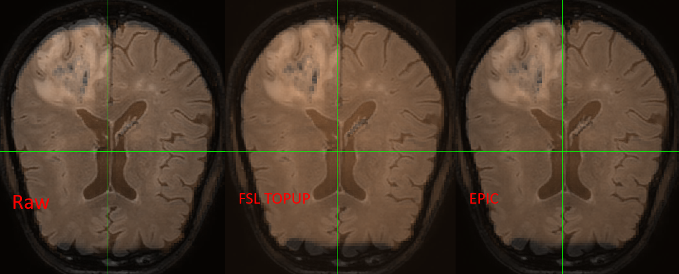
Figure 1: Uncorrected, FSL TOPUP and EPIC corrected gradient-echo EPIs overlaid FLAIR 3D (non-normalized) show significant signal loss in the prefrontal cortex.

