Changes in this version:
- Updated 3 Chemical and biological hazards.
- Changes to performing the risk assessment (Read SOP guide v4 and P-SOP-362)
- Updated 6. Waste disposal; environmental risk.

INTRODUCTION/PURPOSE
Standard procedure for isolation of DNA using a standard CTAB procedure.

NECESSARY SAFETY EQUIPMENT
Remove the non–applicable pictograms
 |  |  | 
 | Nitrile |  | Fume hood



Chemical and biological hazards

Chemicals
List all chemicals used. Information about the chemical can be found in the SDS. Also include in-house reagents as discribed below. Making of in-house reagents should be described separately in a SSOP.
Chemical information | Pictogram(s) and Signal word | Health -, Precautions - and Emergency planning (from SDS) | Intrinsic risk  (Consequence)
Name  e.g. article # and company (link to sds)  CAS no: | 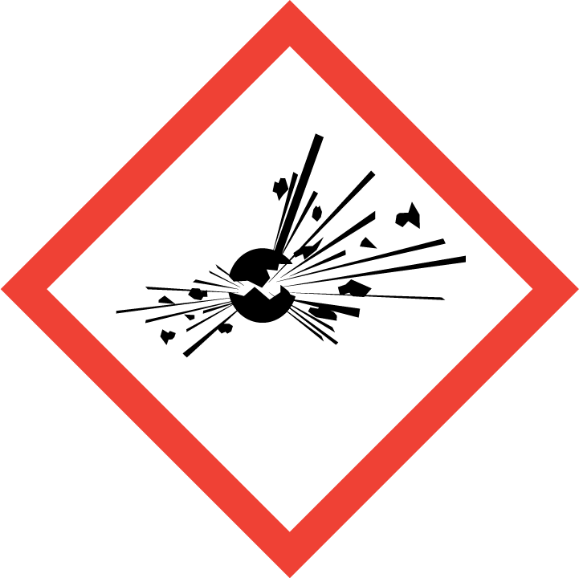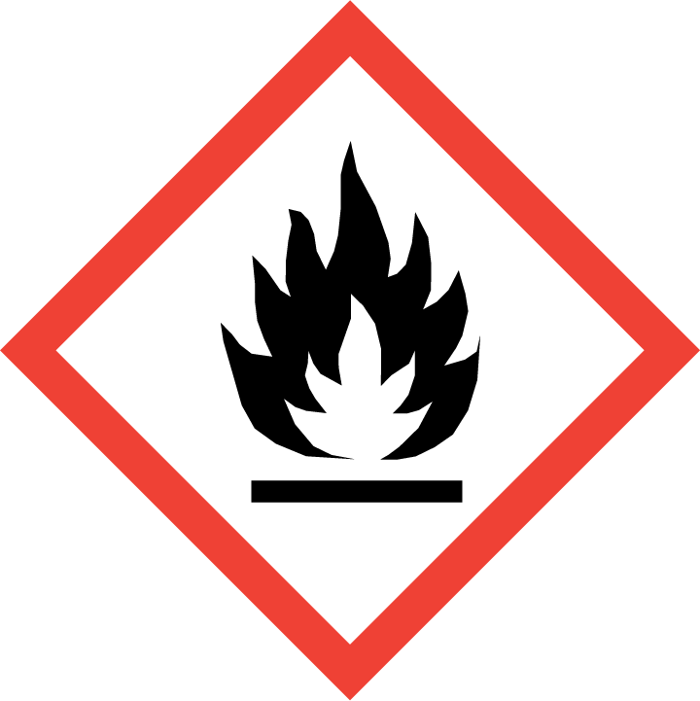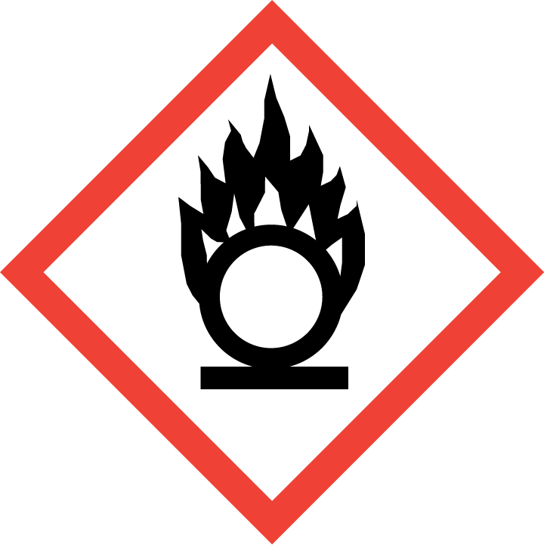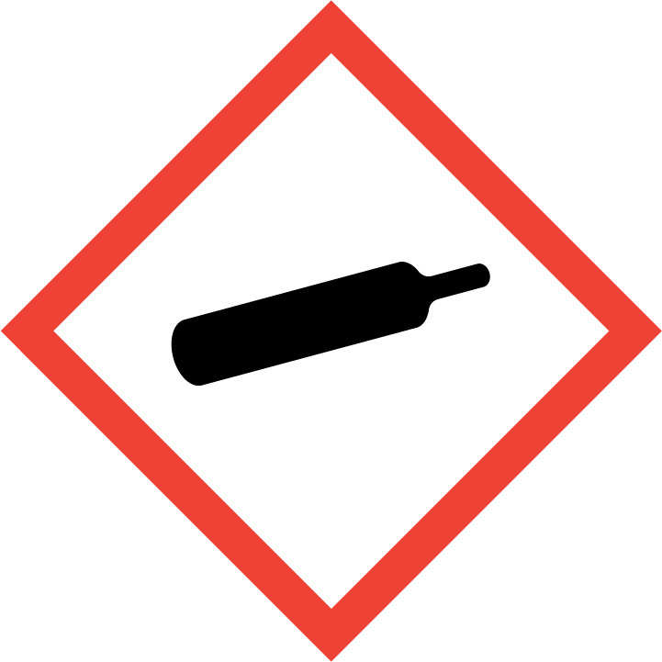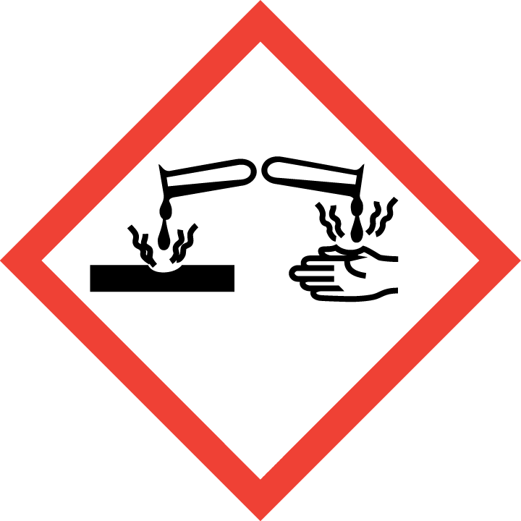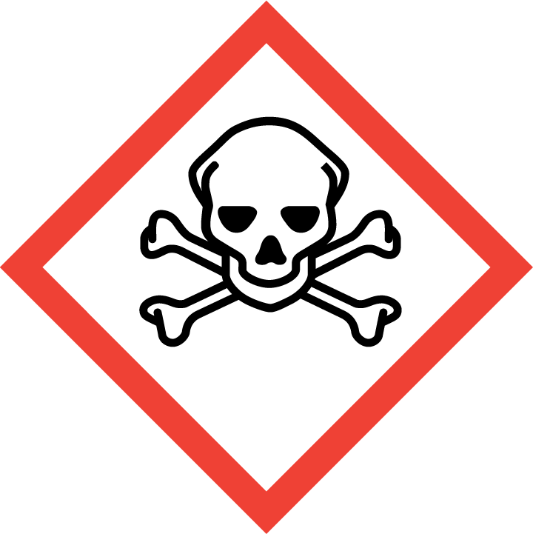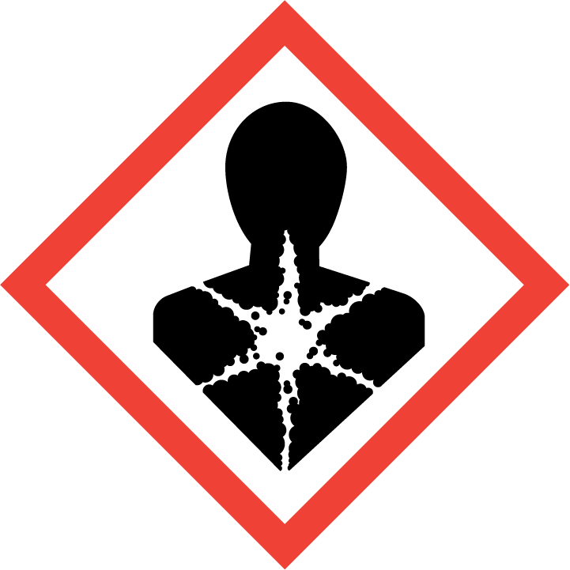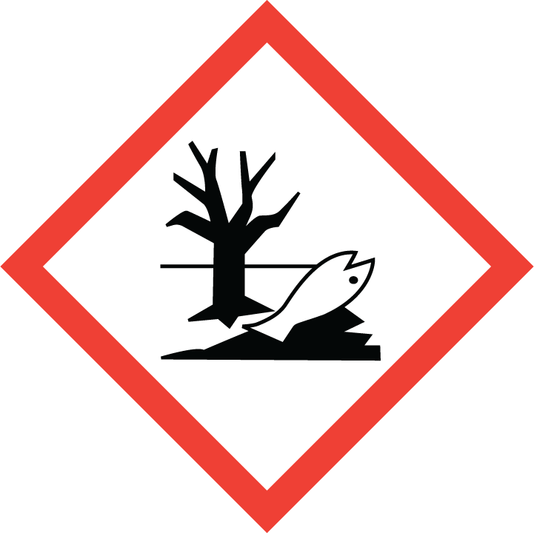  All pictograms in order GHS01-GHS09 | List all H-sentences from sds  List all P sentences from SDS | Based on table 1 below.  Risk without considering any precautions made, both for human and environment.  This will be the K value(s) in the step-by step risk assessment under 5. Procedures
2% CTAB Buffer  A4150 PanReacApplichem (supplied by VWR) |   Warning | H319 (Eye irrit. 2): Causes serious eye irritation.  P280: Wear protective gloves/ eye protection/ face protection.  P305+P351+P338: IF IN EYES: Rinse cautiously with water for several minutes. Remove contact lenses if present and easy to do – continue rinsing  P337+P313: If eye irritation persists get medical advice/attention. | 2 (Humans)  1 (Environment)
2-Mercaptoethanol  M3148 from Sigma Aldrich (MSDS)  CAS no: 60-24-2 | 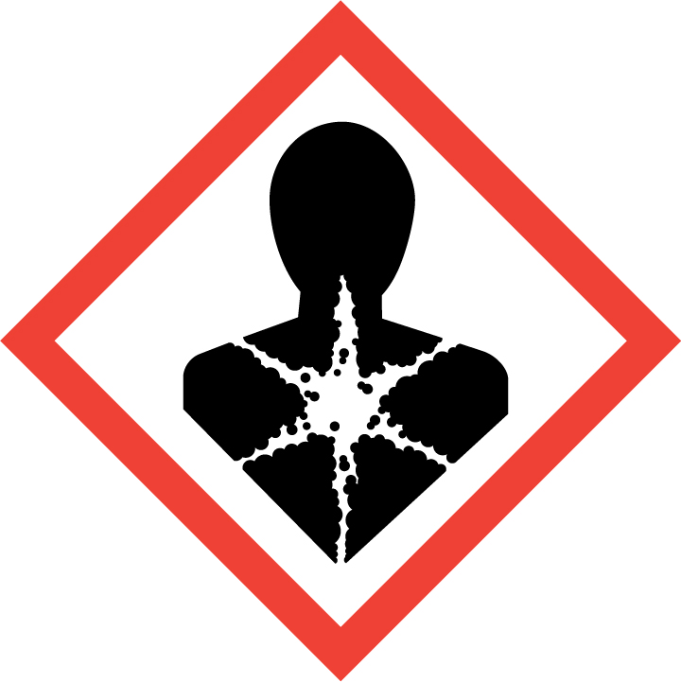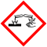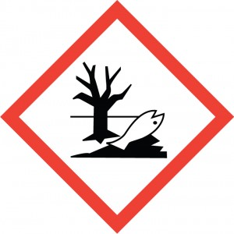  Danger | H301 + H331 (Acute tox. 3):Toxic if swallowed or if inhaled.  H310 (Acute tox. 2): Fatal in contact with skin.  H315 (Skin Irrit 2): Causes skin irritation.  H317 (Skin sens. 1A): May cause an allergic skin reaction.  H318 (Eye dam 1): Causes serious eye damage.  H361d (Repr. 2): Suspected of damaging the unborn child.  H373 (STOT RE 2): May cause damage to organs (Liver, Heart) through prolonged or repeated exposure if swallowed.  H410 (Aquatic Acute 1; Aquatic Chronic 2): Very toxic to aquatic life with long lasting effects  P261: Avoid breathing vapours.  P273: Avoid release to the environment.  P280: Wear protective gloves/ eye protection/ face protection.  IF SWALLOWED: Immediately call a POISON CENTER or doctor/ physician. IF ON SKIN: Gently wash with plenty of soap and water.  IF IN EYES: Rinse cautiously with water for several minutes. Remove contact lenses, if present and easy to do. Continue rinsing. | 5 (Humans)  4 (Environment)
2-Mercaptoethanol  M3148 from Sigma Aldrich (MSDS)  CAS no: 60-24-2 | Danger | Reduced Labeling (<= 125 ml)  H301 + H331 (Acute tox. 3):Toxic if swallowed or if inhaled  H310 (Acute yox. 2): Fatal in contact with skin.  H317 (Skin sens. 1A): May cause an allergic skin reaction.  H318 (Eye dam 1): Causes serious eye damage.  H361d (Repr. 2): Suspected of damaging the unborn child.  P280 Wear protective gloves/ protective clothing/ eye protection/ face protection.  P301 + P310 IF SWALLOWED: Immediately call a POISON CENTER/ doctor.  P302 + P352 + P310 IF ON SKIN: Wash with plenty of water. Immediately call a POISON CENTER/ doctor.  P304 + P340 + P311 IF INHALED: Remove person to fresh air and keep comfortable for breathing. Call a POISON CENTER/ doctor.  P305 + P351 + P338 IF IN EYES: Rinse cautiously with water for several minutes. Remove contact lenses, if present and easy to do. Continue rinsing. | 5 (Humans)  1 (Environment)
Chloroform  e.g. 372978 from Sigma Aldrich  CAS no: 67-66-3 | Danger | H302 (Acute tox. 4): Harmful if swallowed.  H315 (Skin irrit. 2): Causes skin irritation.  H319 (Eye irrit. 2): Causes serious eye irritation.  H331 (Acute tox. 3): Toxic if inhaled.  H336 (STOT SE 3): May cause drowsiness or dizziness.  H351 (Carc. 2): Suspected of causing cancer.  H361d (Repr. 2): Suspected of damaging the unborn child.  H372 (STOT RE 1): Causes damage to organs through prolonged or repeated exposure  H412 (Aqu. Chronic 3): Harmful to aquatic life with long lasting effects.  P273 Avoid release to the environment.  P301 + P312 + P330 IF SWALLOWED: Call a POISON CENTER/ doctor if you feel unwell. Rinse mouth.  P302 + P352 IF ON SKIN: Wash with plenty of water.  P304 + P340 + P311 IF INHALED: Remove person to fresh air and keep comfortable for breathing. Call a POISON CENTER/ doctor.  P308 + P313 IF exposed or concerned: Get medical advice/ attention. | 5 (Humans)  4 (Environment)
Isopropanol  e.g. 278475 from Sigma Aldrich  CAS no: 67-63-0 | Danger | H225 (Flam. Liq 2): Highly flammable liquid and vapour.  H319 (Eye irrit. 2): Causes serious eye irritation.  H336 (STOT SE 3): May cause drowsiness or dizziness.  P210 Keep away from heat, hot surfaces, sparks, open flames and other ignition sources. No smoking.  P261 Avoid breathing vapours.  IF IN EYES: Rinse cautiously with water for several minutes. Remove contact lenses, if present and easy to do. Continue rinsing. | 2 (Humans)  1 (Environment)
Isopropanol  e.g. 278475 from Sigma Aldrich  CAS no: 67-63-0 | Danger | Reduced labelling (≤ 125mL)  H319 (Eye irrit. 2): Causes serious eye irritation. | 2 (Humans)  1 (Environment)
70-75%EtOH (diluted from 96%)  KilltoClean AB (from Sentrallageret)  CAS no: 64-17-5 | Danger | H225 (Flam. Liq. 2): Highly flammable liquid and vapour.  H319 (Eye irrit. 2): Causes serious eye irritation  P210 Keep away from heat, hot surfaces, sparks, open flames and other ignition sources. No smoking.  P233 Keep container tightly closed.  P240 Ground and bond container and receiving equipment.  P241 Use explosion-proof electrical/ ventilating/ lighting/ equipment.  P242 Use non-sparking tools.  P305 + P351 + P338 IF IN EYES: Rinse cautiously with water for several minutes. Remove contact lenses, if present and easy to do. Continue rinsing. | 2 (Humans)  1 (Environment)

Biological Agents
If you are working with biological hazard you should use this table and information from the PSDS. If not cut out
Biological agent | Laboratory hazards, necessary precautions and emergency planning (from PSDS) | Intrinsic risk  (Consequence)
Neisseria gonorrheae  Risk Group 2  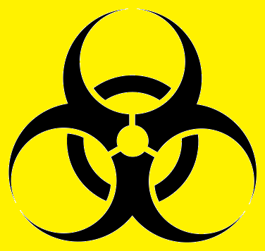 | Containment Level 2 facilities is required  Reported laboratory acquired infections:  - Gonococcal conjunctivitis (eye)  - Cutaneous infections (skin)  The bacteria are mostly known for causing Genital gonorrhoeae  Wear safety goggles, lab coat and gloves.  Avoid contact with contaminated gloves  Wash hands after work  If exposed seek medical assistance. | 2 (Humans)

Special cautions necessary due to reproductive toxicity
Generally, it is not recommended to work with a chemical that has carcinogenic or reproductive effects if you are planning to be or are pregnant. If a chemical is proven to pass into breast milk it is not recommended to perform procedure if you are breast feeding.

If you are working with Class II biological agents that may cause infections, you should consider the risks using the relevant PSDS and other relevant documentation.

Planning pregnancy (men and women): Not recommended to perform this procedure.
Pregnant: Not recommended to perform this procedure.
Breast feeding: None.

PROCEDURE and risk assessment
Describe method and include a stepwise risk assessment. The risk assessment follows the UiO procedure for general risk assessment and we are using a 5*5 risk matrix.

Unwanted scenarios- suggestions
- Spillage on skin
- Inhalation
- Splash in eye
- Needle/Sharps stab
- Environmental spillage
- Burns
Risk – S*K
The K-values (Consequence) are the intrinsic risks stated in 3.1 Chemicals and/or 3.2 Biological agents.
The S-value is derived using the table and description below:

Table 2: Description PROBABILITY
 | Probability (S) | Description
1 | Very small | < 1x per 50 yrs or rarer
2 | Small | < 1x per 10 yrs or rarer
3 | Medium | < 1x per yr or rarer
4 | High | 1x per month or more often
5 | Very high | Weekly

This is the probability (how often) of an incident to occur after we have introduced the necessary precautions and they are being followed. Reported deviations are one way of measuring the probability of an incident occurring, but since we are relatively bad at reporting these unwanted instances, we don’t have good statistics here and where we actually end up with qualified guessing.

Steps where S*K=1, the risk assessment table can be removed from the procedure.

Colour |  | Description
Red | 10-25 | Unacceptable risk. Actions must be performed to reduce risk
Yellow | 4-9 | Assessment area. The need for further actions to reduce risk should be assessed.
Green | 1-4 | Acceptable risk. Further actions can still be made.

Necessary equipment:
List the necessary equipment.
Pipettes
Pipet tips, assorted sizes
Eppendorf tubes (2 and 1,5mL)
Micro Centrifuge
Mixer Mill / TissueLyzer
Crushing beads
Heating Block

Optional: Preparing 2%CTAB buffer with 2-mercaptoethanol. The 2% CTAB that we buy does not contain 2-Mercaptoethanol; you have to add this yourself.

Remember to wear gloves and lab coat and perform the procedures in the fume hood.
- Pour 50mL 2%CTAB buffer into a 50mL Falcon tube.
Part of procedure | Unwanted scenarios | Preventive measures | Risk - S*K  (Probability*Consequence)
1 | Spillage of hazardous chemical | Wear gloves, eye protection and lab coat. | 1*2
- Add 100µL 2-Mercaptoethanol
- Close the lid thoroughly and invert the tube a few times to mix.
2-3 | Spillage of chemical  Inhalation of chemical | Wear gloves and lab coat  Work in fume hood.  Dispose of contaminated gloves inside fume hood. | 1*5
- Wrap the tube in alu-foil and label the tube with contents, your name and date.
Tube should be stored in fume hood or ventilated chemical cabinet prior to use
4 | Inhalation of chemical | Store in ventilated cabinet/fume hood | 1*3 (reduced due to low conc.)

NOTE: If 2-ME is NOT INCLUDED in the CTAB buffer the overall risk of this procedure will be greatly reduced.

DNA Isolation

Notes:
- Work as sterile as possible. Change gloves whenever necessary.
- Always include a negative control.
- Before starting; preheat the heating block to 65ºC

- The material is placed in 2mL eppendorf tubes and 600µl of 2%CTAB buffer is to be added.
- Grind the material. Usually we grind the material using the Retsch MM200 mixer mill. Add 1-2 tungsten-carbide beads to each 2mL tube and grind for 1min at 20-30 Hz, flip the racks and repeat for 1min.
- Place in -80ºC freezer for minimum 10 min. The material can stay in the -80ºC freezer overnight (or longer).
- Incubate the mixture for 30-45 min. at 65ºC. Invert the tubes 2-3 times during incubation. This step lyses the cells.
5-8 | Spillage and inhalation of solution | Wear gloves and lab coat  Work in fume hood  Incubation in fume hood | 1*3 or 1*2 Depending on 2-ME addition?
- Allow the mixture to cool, add 600µl chloroform to each tube and vortex vigorously.
- Centrifuge the mixture for 15 min at full speed (13200 rpm). You can prepare the tubes being used in step 7 while you are waiting. Put them in the fridge to keep them cool once you are done adding the isopropanol. Be careful when taking the tubes out from the centrifuge so that the two layers don’t mix again.
9-10 | Spillage and inhalation of solution | Wear gloves and lab coat  Work in fume hood  Centrifugation in fume hood | 1*5
- Pipet 400 µl of the upper layer (mainly water and DNA) into new 1.5mL tubes containing 400µl of cold isopropanol. Remember to mark the tubes. Be careful not to get any of the lower layer as this includes the chloroform, among others and may contaminate further steps.
11 | Spillage and inhalation of solution | Wear gloves and lab coat  Work in fume hood | 1*2

- Invert the tubes and allow the DNA to precipitate for min. 10 minutes. You can place the tubes in the fridge (~4ºC) overnight.
- Centrifuge at full speed for 10 minutes.
- Carefully pour off the isopropanol and add 300µl cold 70-75% ethanol. Vortex.
- Centrifuge at full speed for 2 minutes.
14-15 | Spillage and inhalation of solution | Wear gloves and lab coat | 1*2
- Carefully pour off the ethanol. Place to tubes on the heating block (60°C) with the lids open until everything has evaporated. To check that there is no ethanol residue, close the tubes and flick them. If you don’t see any drops on the walls of the tubes it is dry.
- Add 60µl of milli-Q H2O to re-suspend the DNA. If you are purifying your DNA with any method, you should check whether to use water for this step or some other buffer.
- Your DNA is now isolated! Store at –20°C. Remember to label your tubes properly with one label on the side of the tube and the extr. ID written on the lid.

Waste management
Describe the different waste types and how to dispose of them. Consider the intrinsic environmental risk of the chemical when assessing the environmental risk.

Waste type |  | Approx volume | Disposal method | Environmental risk
1 | Tips and gloves contaminated with hazardous chemicals | - | Leave in fume hood to evaporate.  Dispose in hazardous waste box. | 1*4 Low risk  This is according to procedure; waste is handled by trained staff and collected by professionals.
2 | Hazardous chemical leftovers | 50mL | Pour into 50mL falcon or other appropriate container.  Leave in fume hood for spills to evaporate and dispose in hazardous waste box. | 1*4 Low risk  This is according to procedure; waste is handled by trained staff and collected by professionals.
3 | Non-hazardous chemical leftovers | 50mL | Pour into 50mL falcon or other appropriate container.  Dispose in hazardous waste box. | 1*1 Low risk  This is according to procedure; waste is handled by trained staff and collected by professionals.

