Changes in this version:
- Updated 3 Chemical and biological hazards.
- Changes to performing the risk assessment (Read SOP guide v4 and P-SOP-362)
- Updated 6. Waste disposal; environmental risk

INTRODUCTION/PURPOSE
This is a procedure including a detailed risk assessment for making 6 % Perchloric acid. 6 % Perchloric acid is used for EtOH concentration determination.

NECESSARY SAFETY EQUIPMENT
Remove the non–applicable pictograms.
 |  |  | 
 | Nitrile |  | Fume hood



CHEMICAL AND BIOLOGICAL HAZARDS

Chemicals
List all chemicals used. Information about the chemical can be found in the SDS. Also include in-house reagents as discribed below. Making of in-house reagents should be described separately in a SSOP.
Chemical information | Pictogram(s) and warning signal | Health -, Precautions - and Emergency planning (from SDS) | Intrinsic risk  (Consequence)
Name  e.g. article # and company (link to sds)  CAS no: | 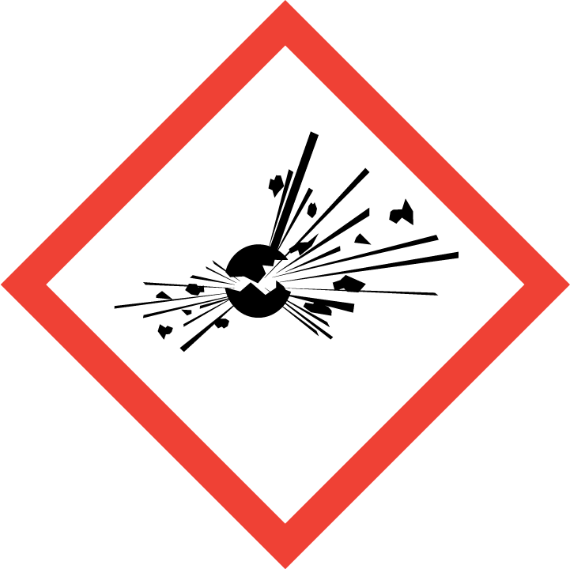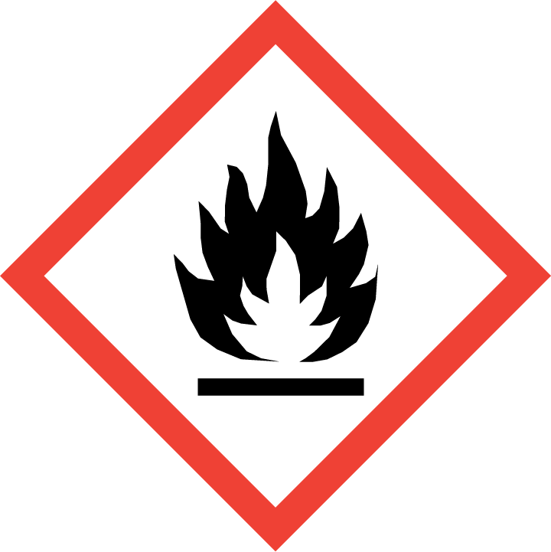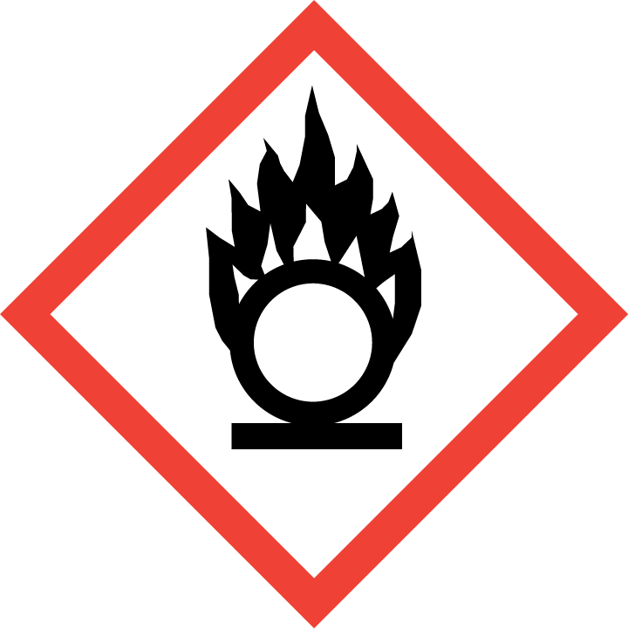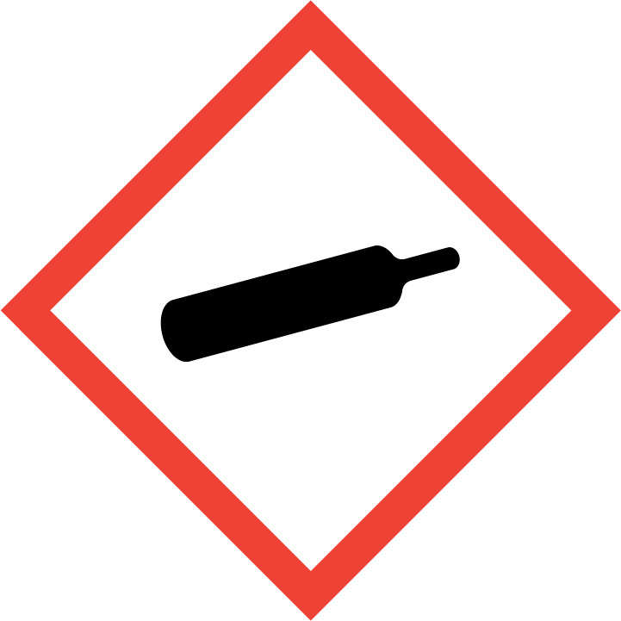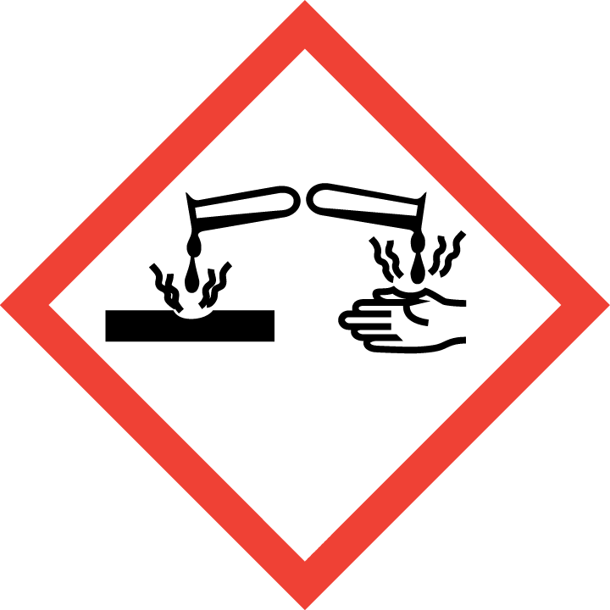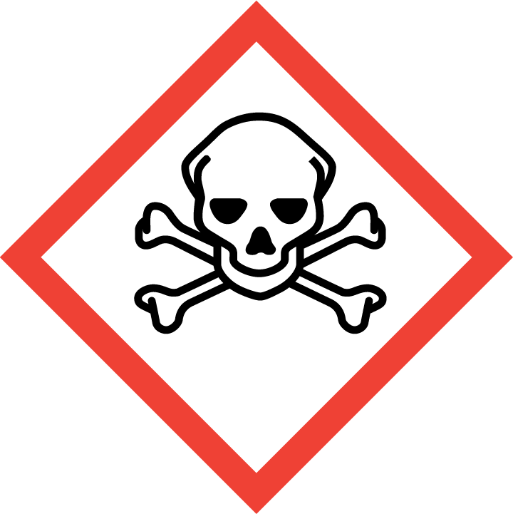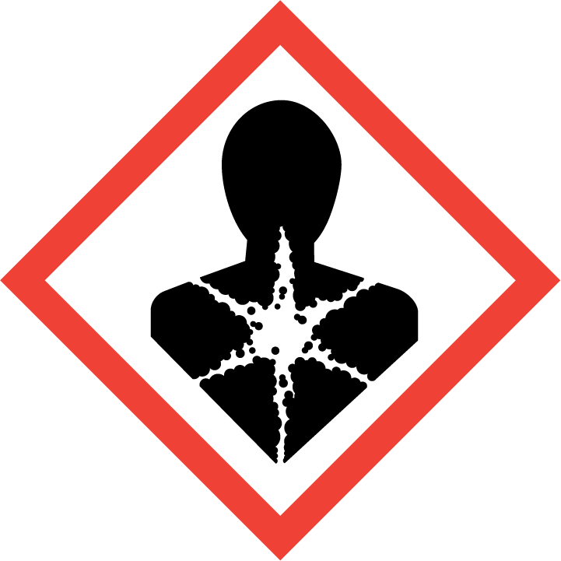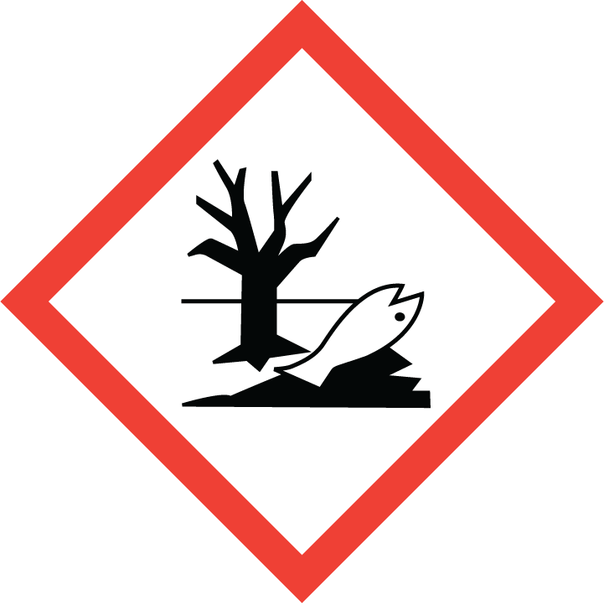  All pictograms in order GHS01-GHS09 | List all H-sentences from sds  List all P sentences from SDS | Based on table 1 below.  Risk without considering any precautions made, both for human and environment.  This will be the K value(s) in the step-by step risk assessment under 5. Procedures
Perchloric acid 70%  311421 from Sigma  CAS no: 7601-90-3 | Danger | H271 (Ox. liq. 1): May cause fire or explosion; strong oxidiser  H290 (Met. corr. 1): May be corrosive to metals  H302 (Acute tox. 4): Harmful if swallowed  H314 (Skin Corr. 1A/Eye Dam. 1): Causes severe skin burns and eye damage  H373 (STOT RE 2): May cause damage to organs through prolonged or repeated exposure  P210: Keep away from heat, hot surfaces, sparks, open flames and other ignition sources. No smoking.  P280: Wear protective gloves/ protective clothing/ eye protection/ face protection.  P303 + P361 + P353: IF ON SKIN (or hair): Take off immediately all contaminated clothing. Rinse skin with water/shower.  P304 + P340 + P310: IF INHALED: Remove person to fresh air and keep comfortable for breathing. Immediately call a POISON CENTER or doctor/ physician.  P305 + P351 + P338: IF IN EYES: Rinse cautiously with water for several minutes. Remove contact lenses, if present and easy to do. Continue rinsing.  P371 + P380 + P375: In case of major fire and large quantities: Evacuate area. Fight fire remotely due to the risk of explosion | 4 (Humans)  3 (Fire)
Perchloric acid 70%  311421 from Sigma  CAS no: 7601-90-3 | Danger | Reduced Labeling (<= 125 ml)  H271 (Ox. Liq. 1) May cause fire or explosion; strong oxidizer.  H314 (Skin Corr. 1A/Eye Dam. 1): Causes severe skin burns and eye damage.  P210 Keep away from heat, hot surfaces, sparks, open flames and other ignition sources. No smoking.  P280 Wear protective gloves/ protective clothing/ eye protection/ face protection.  P303 + P361 + P353 IF ON SKIN (or hair): Take off immediately all contaminatedclothing. Rinse skin with water.  P305 + P351 + P338 IF IN EYES: Rinse cautiously with water for several minutes. Remove contact lenses, if present and easy to do. Continue rinsing. | 4 (Humans)  2 (Fire)

Special cautions necessary due to reproductive toxicity:
Generally, it is not recommended to work with a chemical that has carcinogenic or reproductive effects if you are planning to be or are pregnant. If a chemical is proven to pass into breast milk it is not recommended to perform procedure if you are breast feeding.

Planning pregnancy (men and women): None
Pregnant: None
Breast feeding: None.

PROCEDURES and risk assessment

Procedure
Describe method and include a stepwise risk assessment. The risk assessment follows the UiO procedure for general risk assessment and we are using a 5*5 risk matrix.

Unwanted scenarios- suggestions
- Spillage on skin
- Inhalation
- Splash in eye
- Needle/Sharps stab
- Environmental spillage
- Burns
Risk – S*K
The K-values (Consequence) are the intrinsic risks stated in 3.1 Chemicals and/or 3.2 Biological agents.
The S-value is derived using the table and description below:

Table 2: Description PROBABILITY
 | Probability (S) | Description
1 | Very small | < 1x per 50 yrs or rarer
2 | Small | < 1x per 10 yrs or rarer
3 | Medium | < 1x per yr or rarer
4 | High | 1x per month or more often
5 | Very high | Weekly

This is the probability (how often) of an incident to occur after we have introduced the necessary precautions and they are being followed. Reported deviations are one way of measuring the probability of an incident occurring, but since we are relatively bad at reporting these unwanted instances, we don’t have good statistics here and where we actually end up with qualified guessing.

Steps where S*K=1, the risk assessment table can be removed from the procedure.

Colour |  | Description
Red | 10-25 | Unacceptable risk. Actions must be performed to reduce risk
Yellow | 4-9 | Assessment area. The need for further actions to reduce risk should be assessed.
Green | 1-4 | Acceptable risk. Further actions can still be made.

Necessary equipment:
List the necessary equipment.
Pipettes
Pipet tips, assorted sizes
50 ml glass bottle
MQ water
Magnetic stirrer

We always wear lab coat when working in the lab.

- Add approx. 40 ml with dH₂O to a 50 ml glass bottle.
- Transfer 4.3 ml 70 % perchloric acid to a 50 ml glass bottle.
- Adjust the volume to 50 ml with dH₂O (6 % perchloric acid).

Part of procedure | Unwanted scenarios | Preventive measures | Risk - S*K  (Probability*Consequence)
1-3 | Spillage in eye/on skin of hazardous chemical | Wear gloves, goggles and lab coat. Work in fume hood  Add most of water before adding the acid  Locate nearest fire extinguisher | 1*4

- Mix on magnetic stirrer.
- Label the bottle with 6 % Perchloric acid and hazard symbol according to the risk conclusion, date and your name and store in the fridge.
4-5 | Spillage of hazardous chemical | Wear gloves, goggles and lab coat. Work in fume hood | 1*2 (from 5.2)

Labelling of new solution:
Please find relevant classification information from existing sds and the information in P-SOP-362 (this might be quite time consuming).
We here look at the different H sentences found in sds (also section 3.1 in SOP)
What happens to H271 (Ox. liq. 1): May cause fire or explosion; strong oxidiser?
In the sds pt. 3.2 we find this information:
Concentration limits:
> 50 %: Ox. Liq. 1, H271
<= 50 %: Ox. Liq.2, H272

Below 50% the classification is reduced to H272 %: Ox. Liq.2, so that is our new labelling for this point.
What happens to H290 (Met. corr. 1): May be corrosive to metals?
There is no cut-off limits for this hazard class, so it will follow the new solution.
However:
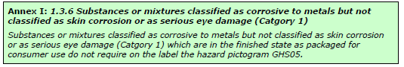
Figure 1; Snip from Echa guide
So the pictogram can be removed, since there is a change in H314 (see last what happens…)
What happens to H302 (Acute tox. 4): Harmful if swallowed?
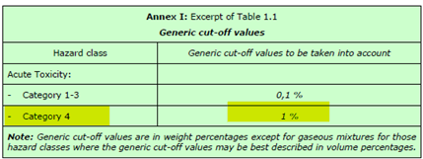
Figure 2: Snip from Echa guide
Cut off is 1%, soln. is 6%, hence H302 needs to be there.
What happens to H373 (STOT RE 2) May cause damage to organs through prolonged or repeated exposure?
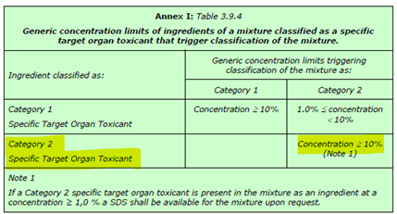
Figure 3: Snip from Echa guide
Concentration limit is ≥10%; new concentration is below 10%; this H sentence can be removed.
What happens to H314 (Skin Corr. 1A/Eye Dam. 1): Causes severe skin burns and eye damage?
In the sds pt. 3.2 we find this information:
Concentration limits:
>= 50 %: Skin Corr. 1A, H314
10 - < 50 %: Skin Corr. 1B, H314
1 - < 10%: Skin Irrit. 2, H315
1 -< 10 %: Eye Irrit. 2, H319

We find that our solution of 6% is in the highlighted range; hence the labelling is reduced to:
H315 (Skin Irrit. 2) and H319 (Eye irrit. 2).

Actual labelling of new solution:
Perchloric acid 6%  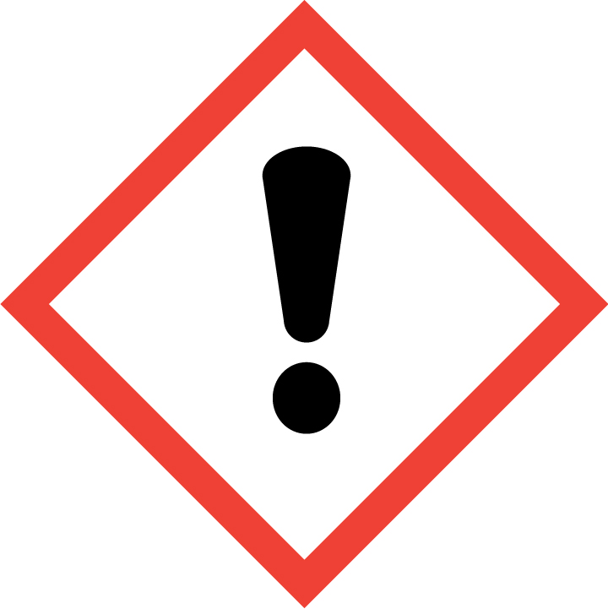 | H272 (Ox. Liq. 2): May intensify fire; oxidiser  H290 (Met. corr. 1): May be corrosive to metals  H302 (Acute tox. 4): Harmful if swallowed  H315 (Skin Irrit. 2): Causes skin irritation.  H319 (Eye irrit. 2): Causes serious eye irritation  P210: Keep away from heat/sparks/open flames/hot surfaces. — No smoking.  P280 Wear protective gloves/protective clothing/eye protection/face protection  P301+P312: IF SWALLOWED: Call a POISON CENTER or doctor/physician if you feel unwell.  P302+P352: IF ON SKIN: Wash with plenty of soap and water.  P332+P313: If skin irritation occurs: Get medical advice/attention.  P305 + P351 + P338: IF IN EYES: Rinse cautiously with water for several minutes. Remove contact lenses, if present and easy to do. Continue rinsing.  P337 + P313: If eye irritation persists: Get medical advice/attention.

WASTE DISPOSAL
Describe the different waste types and how to dispose of them. Consider the intrinsic environmental risk of the chemical when assessing the environmental risk.

Waste |  | Volume | Disposal method | Environmental risk
1 | 70 % perchloric acid  Disposal of chemical; too much volume taken out from bottle, the stock solution of 70% perchloric acid is out of date etc. | 0.1 – 100 ml | See chemical waste procedure (Farlig avfall) | 1*3 Low risk  Chemicals for disposal are stored in locked ventilated chemical cabinets.  The disposed chemicals are collected twice a year by professionals.
2 | Contaminated disposables or small chemical spillage with 70% perchloric acid | 0.1 – 1 ml | Yellow hazardous waste containers | 1*3 Low risk  This is according to procedure; waste is handled by trained staff and collected by professionals.
3 | 6 % perchloric acid  Rest of solution that is too old. | up to 50 ml | See chemical waste procedure (Farlig avfall) | 1*2 Low risk  This is according to procedure; waste is handled by trained staff and collected by professionals.

REFERENCES

