Improving offshoring of low-budget agile software development using the dual-shore approach: an autoethnographic study
Michael Thorkild Nørgaard Jørgensen 1,2, Harald Hovmøller ^{1,3}, Jesper Riber Nielsen^{1,4} and Torben Tambo1,5,

1AU Herning, School of Business and Social Science, Aarhus University,
Birk Centerpark 15,
7400 Herning, Denmark
2mtnj90@gmail.com, 3harald.hovmoeller@gmail.com,
4Jesper@ribers.info, 5torbento@hih.au.dk
Abstract. This paper examines how agile software development can be implemented in an offshore setting by introducing and testing the dual-shore approach. The topic is further enlightened by an analysis and discussion of an empirical autoethnographic study proposing three specific suggestions for improvements of a particular agile offshoring process. Furthermore, the discussion leads to a modification of the original dual-shore approach to fit the characteristics of low-budget development projects. The article explains agile development and elaborates the four basic principles associated with it. The four principles are then used as a framework throughout the article. A short introduction to the terms outsourcing and offshoring is given, and it is illuminated how agile processes can be implemented into offshored development. The most common difficulties regarding agile offshoring are described and the dual-shore model is introduced as a tool to improve communication in an agile offshore setting. A qualitative case is presented highlighting the methodological concepts. Key contributions are that the dual-shore model is suggested to be supplemented with Exemplary Business Process Models extended beyond the onshore team and partially presented to the offshore development team, the metaphorical layers of the dual-shore approach is specifically included, and a design of an online start-up meeting is proposed.
Keywords: Agile development, agile offshoring, dual-shore, software development, low-budget projects, Exemplary Business Process Models.
1 Introduction
Agile software development methods are becoming widely recommended practices in IT companies as well as object of widespread academic interest [41]. Using agile software development methods to produce software is quicker and customer specifications are used more iteratively. The agile development process is flexible and alleviates traditional development challenges [1] such as responding to change and customer collaboration [2]. Based upon the fact that developing software across borders is also becoming a major trend in the IT industry [3], there is a rather extensive body of literature examining the effect that offshoring software development has on the agile development process [2][4][5].
The main focus of this article will be to review the theory - within the topic to gain an understanding of key parameters in successful agile offshoring software development. As a secondary agenda, the key project types discussed are small, low-budget development projects that have traditionally been difficult to bring into offshoring due to project management overhead cost. As agile methods in offshoring are not uncommon, this paper is aiming at understanding and improving the communication and knowledge transfer processes between the three involved parties.
The review of theory is divided into three sections. The first section deals with theory on the core concept of agile software development will be reviewed, bringing insight into agile software development in its traditional form. Next, to gain an understanding of the term offshoring and the possible pitfalls connected with this specific approach, literature on the topic is examined. These two sections of the theory review should act as a preliminary research leading to the third and final section, namely, as mentioned earlier, theory referring to the effects offshoring might have on agile software development and how to avoid these.
An autoethnographic methodology [6][7] is used to study processes of agile offshoring from the inside. The methodology encompasses establishing a company and engaging with customers and suppliers while maintaining a research perspective. By analysing the project executed, the theoretical insight is substantiated with continuously available empirical data.
The research purpose of this article is to clarify how offshoring agile software development could be performed using the four principles of agile development [8]. Furthermore, the purpose is to illustrate the theory by analysing an autoethnographic study reviewing how the dual-shore approach could improve the process, leading to a discussion of the practicality of the dual-shore approach in low-budget projects [9].
2 Literature Review
In the following, a literature review is being presented, starting with a description of classic agile development and followed by a clarification of offshoring and outsourcing. Then, a description of the issues in offshoring combined with agile development is executed. The literature review is concluded by introducing the dual-shore approach which includes solution-oriented tools in handling agile offshoring development.
2.1 Agile software development
The agile software development concept was originally introduced around year 2000 [10][41], but the fundamental research of agile or “disciplined problem development” [11] was notably introduced by Takuchi and Nonaka [12][13][14] who contemplated that factors such as low costs of delivery differed – and high-quality products were not enough to succeed in a competitive market. Instead, companies must deliver products faster and with a higher flexibility. Today, this is one of the key justifications of agile product development [15].
Agile development differs from traditional methods and plan-based approaches. The plan-based approaches stick to the term that every part of the project can be carefully planned and specified before the actual development starts [16]. These methods are often used in larger and more critical projects running over several years, where room for specification changes is often not welcome. When developing smaller software projects using carefully planned project models, the time spent on overall system design is often higher than the time spent on the actual development [17]. Instead of focusing on system design, agile methods are targeted on producing software faster and making room for dynamic specification changes while developing (due to changes in user requirements). Agile methods are largely question of communication and learning [15] and knowledge management [41].
To better understand the principles of agile software development, the Agile Alliance [8] created a manifesto based on four different values described below [10].
1. Individuals and interactions over processes and tools. The point of these values is that individuals (e.g. programmers, testers and customers) and their way of interacting with each other is more important than having the right tools and processes, such as Gantt planning tools and stage gate development processes [18]. This does not mean that these processes and tools are unnecessary but having the right people working on the product is more important. Even though this sounds reasonable, it is still difficult to gain management acceptance to this methodological position based on desires to be independent of individuals, create legal documentation and generally maintain control [19].
2. Working software over comprehensive documentation. The main role of documenting software is to communicate the software between individuals (e.g. client and programmers), and strong documentation is therefore normally seen as a necessarily tool for producing software [20]. When the documentation is too comprehensive, like complex diagrams and technical specifications, focus is lost from creating quality software and creating documentation is becoming an objective of it own [10].
3. Customer collaboration over contract negotiation. Developing software in collaboration with a customer is often based on functional requests that the software development company subsequently translates into specifications used for development. But often the customer expressions are ambiguous, open-ended and with tacit connotations, and the expectation-perception is prone to change during the project period, effecting a change in specifications over time, which is difficult to specify in a contract. Instead the customer collaboration should be based on a contract containing a common understanding of everyone’s responsibilities and rights [10]. This is also the reason why many agile software development contracts are based on an hourly paid basis instead of at fixed price, which also creates trust and ties the customer closer to the development process [21].
4. Responding to change over following a plan. As mentioned above, requirements change during the project period which may be due to changes in the project stakeholders’ understanding of the project or changes in technology [10]. When operating in these changing environments, it is not possible to have fixed project management charts since, upon changes the management charts become irrelevant or outdated; instead the planning should be flexible, dynamic and iterative [10][22].
Agile as well as structured methods have strengths and weaknesses. Estler et al. [42] show from their review of 66 projects no significant difference in outcome related to approach. However, subsequently it is assumed that smaller projects would match the agile approach better.
2.2 Offshoring and outsourcing
“Outsourcing is the use of external companies to perform services, rather than using internal staff” [2]. Offshoring is a variant of outsourcing where companies relocate business functions and structures to other and often low-wage countries [5]. According to the Danish government agency “Research and Innovation”, offshoring is the same as “outsourcing to another country” [23].
Motives for offshoring are primarily cost reductions. But benefits like increased flexibility, core business focus or employment of qualified staff can also be factors that drive offshoring [24]. Empirical studies have shown that offshoring also contains numerous problems such as geographical distance, time zones difference, cultural, social and political differences and other factors [5].
Furthermore, offshoring tasks related to geographically separated onshore and offshore teams are often very complex both due to the challenge of distance and multiple organisations, but also factors related to language, cultural and temporal differences have an influence on the complexity [5][25].
According to Kornstädt and Sauer [9], software development is one of the industries that experiences outsourcing of tasks to low-wage countries. It is stated that classic offshoring works best in stable environments where specifications are final and a piece of software is delivered. However, as described in the previous sections, many software development projects are too complex to be handled in this way [9], or too small to justify the overhead of thorough specifications.
To deal with projects of rapidly changing requirements, agile development approaches can be used to establish greater flexibility [5].
2.3 Offshoring and agile software development
Braithwaite and Joyce [26] define agile offshoring as: “an agile team is created at an appropriately low cost offshore location. Requirements are generated onshore, and communicated offshore using documents, people and tests.” Sauer [5] presents a framework that highlights the challenges regarding implementing agile offshoring. The challenges are classified according to the four agile values defined in section 2.1.
Working software over comprehensive documentation
Communication is the key issue when it comes to individuals and interaction [27][43]. Rooted in the offshoring projects geographically organised as distributed teams, communication possibilities between teams are limited [26]. Problems that are easily solved in face-to-face meetings now have to be solved through telephone, videoconferences or chats. This is time-consuming and can be further complicated by difference in time zones and work rhythms [27][28].
As described, the distributed environment makes everyday communication difficult, which according to research decreases coordination efficiency and leads to less flexible processes. To cope with these challenges, publications propose that a team’s common knowledge is built up and maintained explicitly [5][43].
Customer collaboration over contract negotiation
Problems in this area can be regarding shared version controls. When teams do not work side by side, it is harder to generate a mutual perception of the progress in the development process [28]. Empirical studies also indicate that insufficient design capabilities of offshore developers can be a problem and that it is not easy to guide weaker or less experienced programmers over the long distances. Furthermore, different perceptions of adequate quality can also cause problems [5].
Responding to change over following a plan
The customer collaboration is obviously subjected to the same limitations in terms of geographical, cultural and time-zone differences as geographically distributed teams [29]. Therefore, a requirement analysis and frequent interactions with the customer can be problematic to perform. This can lead to a gap between the required specifications and the delivered application. Research also suggests that the establishment of a friendly atmosphere and credibility can be difficult [5].
Offshoring and agile software development
Because of the distance between team members, it can be difficult to keep an overview of the project progress and project management, and controlling is not easy. In addition, communication with developers regarding development costs and estimation can be negatively affected [30]. According to research, it is desired to establish knowledge transfer from onshore to offshore in order to involve the offshore team and make it achievable to ship as many task as possible offshore [5].
2.4 Dual-shore approach
Kornstädt and Sauer [9] present an approach for avoiding pitfalls in offshoring agile software development, called “The dual-shore approach”, which is basically an extension of the “Tools and Materials” (T&M) approach [31].
The term “dual-shore” is used to describe a certain type of development setting where development is carried out both onshore and offshore. The onshore team consists of local developers who deal with the business-related issues of development, such as understanding customer needs and generating specifications. The offshore team primarily focuses on the engineering of software and has no direct customer interaction.
When software development is organised as offshoring, communication precision is one of the main challenges [32]. The dual-shore approach takes this into account, providing a set of methods for establishing common understanding of a project. It also ensures agility in offshoring projects by applying practices like continuously adjusting the development process through iterations and improving communication [33]. Figure 1 shows the most relevant processes in the dual-shore approach.
When a project has been initiated, onshore developers and offshore developers work in parallel to each other. Onshore developers work as a mediator between the customer and the offshore developers. They participate in iterations with both the customer and the offshore team throughout the entire development process. This is done to accommodate new or changed customer needs, and to pass this information on to offshore developers without any misunderstandings.
The dual-shore approach presents different communication precision methods that are important when trying to improve communication [26].
Metaphors, Exemplary Business Process Models (EBPMs), design and conceptual patterns as well as sound software architecture are all methods that improve onshore developers’ understanding of the custumer’s environment and help the onshore developers mediate between the customer and offshore developers [9].
Metaphors are used to develop a common understanding of the core concept behind the software to be developed, both in the communication between onshore developers and customers, and between onshore developers and offshore developers. Metaphors work as a helpful resource when trying to pass on messages with a high level of complexity, especially when communicating across borders. Metaphors are split into two categories; Guiding metaphors and metaphors.
“For generic office applications, the guiding metaphor “Expert Workplace” is a good fit: It is easy to envision Tools, Materials, Automatons (such as a calculator), Containers (such as folders) and a Working Environment (such as a desk with in and out boxes) at an Expert Workplace” [9] p87.
Metaphors are a layer on top of guiding metaphors and are used to elaborate the guiding metaphor if necessary.
EBPMs [34] help onshore developers gain an understanding of how the customer envisions the overall functionality of the software. An EBPM exemplifies everything from what specific user interaction should result in to how and when certain processes should be performed in the software and by whom.
When onshore and offshore developers communicate, design and conceptual patterns are used as an additional layer on established metaphors.

Figure 1. The dual-shore approach from Kornstädt & Sauer

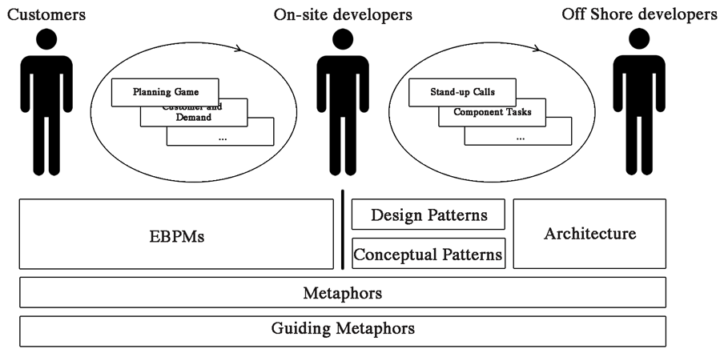

The key elements of figure 1 contribute to a further and more detailed understanding of the software than the one obtained when explaining the core concept through metaphors alone. Where conceptual patterns state how the software behaves, the design patterns describe the interaction between different parts of the software. To communicate the software architecture is also of great importance. The software architecture is the blueprint of the development process, and helps developers maintain control in a complex system.
In short, the dual-shore approach is an offshoring setting that enables low development costs, agility in an offshoring development process and increases the success rate and quality in offshoring projects.
3 Research Design
The research design for the project of this paper uses Crotty’s [35] research matrix, starting by describing the philosophical worldview, followed by a research strategy and finally describing the research techniques.
The social constructivist’s philosophical worldview perspective is used throughout the project. This perspective is used as the research team believes that the consensus is not only created by the single individual, but also in a social context based on relevant social and cultural constructions [35][36].
The research strategy used in this project is based on an autoethnographic approach. Autoethnography is a variety of ethnography, meaning studying a cultural group over a certain time period, primarily done by observing and interviewing [37] with a strong role of the self of the researcher. The difference between these two approaches is that within the autoethnographic approach the research team is part of the object being researched [6]. By using the researcher’s perceptions and experiences as an important part of the construction in the researched field, the distance to hands- on data can be minimised. When using the research team as the researched object, there are some pitfalls one of which is related to the fact that it can be difficult to step aside and make correct and unbiased observations [6]. The research employed the guidelines from [6][7][37] in order to minimise the bias. Three members of the author-team have created the entrepreneurship organisation that is the object of the study, and will be described further in the empirical section. All members basically had the same roles within the team however some division of work existed with (1) customer relations, (2) supplier relations, (3) technology/deliverable coordination.
A deductive approach [7][38] has been used because the goal of this project is to generate knowledge within offshoring agile software development based on a well-defined theoretical foundation. The data inquiry is based on the theoretical framework derived from the four agile principles. The empirical data is collected during the development of a smartphone application corresponding to two months, and are documented as narrative descriptions by having the research team interviewing each other [7]. Furthermore, reactions from the customer and the offshore development team were recorded, and finally “objective” data was included: Requirement specifications, database interface description, the document flow between the three parties, test reports, customer change requests and the developed software.
4 Empirical Work
Section 4.1 describes the setting of the empirical data collection and the application of the autoethnographic approach. Sections 4.2- 4.5 follow the four agile principles in respect to relations and interaction.
4.1 Autoethnographic settings
APPbility is a small Danish software company with a total of four staff members. The company has specialised in the development of B2B mobile applications through offshoring of the software development to lower wage countries. APPbility has worked with suppliers from Serbia. This ethnographic study deals with a specific project regarding an iPhone application for a Danish customer. The purpose of the application was to replace the costumer’s old manual laser scanners used in showrooms and on exhibitions with an iPhone application, creating different new possibilities for the customer in their business processes.
In the project, APPbility’s Danish engineers were located onshore doing requirement analysis, concept development, graphic design and customer collaboration, while all software development was carried out by the Serbian software team.
Before the project started, a collaboration agreement between the Serbian development company and APPbility was made. The collaboration agreement described general business terms, such as when and how payment should be made, and how specification changes should be handled.
The duration of the project was two months and at no point during the project did the onshore team or the customer meet the offshore developers physically. In total, 470 effective man-hours were used from the concept development to final delivery of the product (as shown in the table below).

Table 1. Project hours
Task | On-shore team  hours | Off-shore team  Hours
Concept development | 15
Project planning | 25
Communication with off-shore team | 100
Communication with customer | 100
Coding |  | 190
Testing | 40
Sum | 280 | 190

Besides the role of being an intermediate in the process between developer and customer, the setting is intended to be an experimental platform of organising software offshoring, customer interaction and entrepreneurship. Projects are continuously being closely monitored and reflected, and organisational learning is critical.
4.2 Individuals and interactions over processes and tools
As described in the method section, the empirical observations are divided into the four basic principles of agile software development. Subsequently, the handling of the four agile principles throughout the project and how the APPbility staff experienced the process will be presented.
Interactions between onshore and offshore team were done through Skype and email. Between 10 and 120 minutes Skype talking and chatting were conducted each day. The communication with offshore developers was done exclusively by APPbility staff and not the customer.
The dominant issue regarding individuals and interactions can be described as a combination between geographical distance and language. As both the onshore and offshore team had to speak a foreign language (English), difficulties in communicating specifications and design requirements could arise, particularly during the first two weeks where much information concerning the application specifications needed to be transferred from the onshore team to the offshore team. In this preliminary stage of the development process, the geographical distance became an issue. It was not possible to explain details face-to-face which led to misunderstandings, thus requiring extra work in communicating the purpose of the application and its functionalities.
The cultural difference was not perceived as a barrier in general interaction. But because of different religions in Denmark and Serbia, the Christmas holiday is celebrated on different days in the two countries. As a result, some of the staff in Serbia had to work during the holiday season in order to meet changed requirements within a deadline.
The staff of APPbility did not experience that flexibility was affected by the distance between the onshore and offshore developers. The developers’ constant availability on Skype was stated as the main reason to answer questions quickly when needed.
4.3 Working software over comprehensive documentation
Before the Serbian development team started the software production, the onshore team made a set of documentation. The documentation consisted of two parts; a simple mock-up document showing visual depictions of the application along with a small description for each, and a document describing the links between the client’s existing server and the application in total about 15 pages. The creation of this documentation was very time-consuming, since every detail of the app needed to be communicated and illustrated. In line with Kornstädt and Sauers recommendations, a project specific style of EBPM was introduced from the dialogue between the customer and the onshore team to the offshore team. The EBPM had a propaedeutical character for the testing and learning purpose and is coarsely illustrated in figure 2.

Figure 2. Rich picture used as EBPM illustration
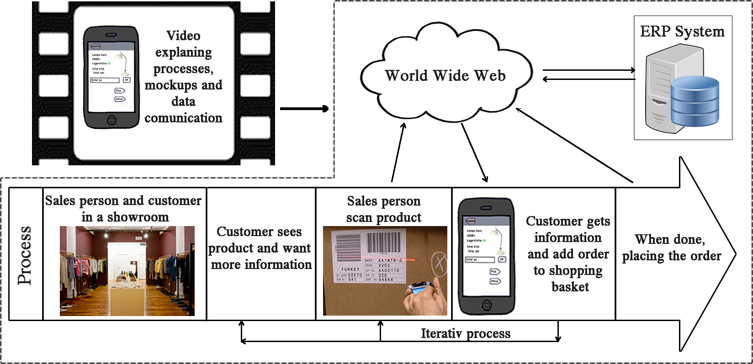
When the software development started, the offshore developers used the simple visual mock-ups quite often, whereas the server description was hardly used due to the complexity. This caused the offshore team to ask questions trough Skype and email, demanding much time spent on reinforming the Serbian offshore team of the server settings.
Offshore developers started by delivering separate parts of the application. Onshore developers then tested these parts in collaboration with the customer and submitted feedback via emails and Skype calls to the offshore developer.
The staff of APPbility and the offshore team relatively quickly gained a mutual understanding of quality and project progress. They even experienced offshore staff suggested improvements and tried to refine the application within the given boundaries.

4.4 Customer collaboration over contract negotiation
As stated earlier, the customer and the offshore developers did not interact. Collaboration between the customer and onshore developers was done through telephone calls and face-to-face meetings. When starting the project, an initial frame of specifications was created and a price was estimated. A contract containing the agreed initial specifications and a fixed price was signed.
Throughout the project, only three face-to-face meeting were held. The frequency of the telephone calls was three calls a week at the beginning of the project and only once a week after that. At the end of the project, testing of the application had to be conducted, which again caused the frequency of telephone calls to be three times a week.
The staff involved described the customer collaboration as being very good and flexible.

4.5 Responding to change over following a plan
It was agreed with the customer that when new specification demands evolved during the project, the customer would pay for the extra hours needed. Smaller changes with the already given specifications were included in the contract’s fixed price.
All tasks regarding cost estimation were done offshore. Subsequently, information on cost estimation of changes had to be adjusted between the offshore and the onshore teams as well as communicated further by the onshore team to the customer for approval.
5 Discussion
The literature review provided knowledge about typical challenges in offshoring of agile software development and how to avoid these using the dual-shore approach [9]. This section will be used to discuss what processes the company from the autoethnographic study should maintain to ensure successful agile offshoring in the future. In the following, a set of suggestions for improvement of agile offshoring of software development will be developed. Subsequently, a revised dual-shore model for use in similar software development projects aiming at low-cost agile offshoring is presented, and finally, the credibility of the findings will be discussed according to the limitations of this article.

5.1 Processes to maintain
In a process perspective on the described project, interaction is a dominant issue. Interaction requires careful scheduling and rescheduling on an ongoing basis to ensure the appropriate flow of information and associated filtering as well as approval processes. Interaction is also a cost factor for the customer, the onshore team and the offshore team – a cost factor both in time spent to exchange information illuminating the assignment, but also interaction to avoid errors.
Frequent iterations. As described in the literature review [4], frequent communication and feedback loops are vital to avoid misunderstandings and ensure an agile development process. The empirical data from this study also shows that frequent and adapted communication is a major precondition for a flexible and well-coordinated offshoring project. The frequent communication between onshore and offshore developers should therefore be maintained in future projects to ensure an agile process [43]. The frequency of scheduled interaction is at best changed dynamically with varying number of calls per day/week. Unscheduled interaction, e.g. chatting, can be valuable in the fine adjustment of information, and is generally less costly.
Customer collaboration and testing. Theory states that a gap between customer expectations and delivered software can arise due to the distance between customer and developers. In the autoethnographic study, small parts of the application were delivered to onshore developers and tested in collaboration with the customer. In combination with short feedback loops, this ensured that the overall development constantly moved in the right direction and a gap therefore did not occur. The partial “micro” delivery, the immediate test possibilities, the organisation of the onshore team close to the customer are key factors in the model perspective of avoiding the misdelivery gap, keeping rework and post-development testing costs down.

5.2 Suggestions for improvements
By using the dual-shore approach, three specific improvement suggestions for APPbility’s agile offshoring process are presented. Where the development organisation is in the middle and has close access to the customer, the offshore team is distant; the suggestions aim for communication, vision & knowledge sharing and collaboration between the offshore and onshore teams to reduce misinterpretations. The following enlightens how the dual-shore approach can be used in practice to improve specific offshoring projects. Finally, the model is revised for use in future agile offshoring projects similar to the autoethnographic study.
1. EBPMs. It is suggested that the development onshore team should benefit from a more effective use of EBPMs (Exemplary Business Process Models) when mediating between the customer and the offshore team. The autoethnographic study points to troubles in passing on information about the software specifications and architecture to the offshore team. By creation of EBPMs from initial specification iterations with the customer, these EBPMs should be forwarded to the offshore team, providing them with a more illustrative understanding of the software to be developed. In this way, the onshore team and offshore developers can avoid relying on the English language as the only means of creating a common frame of reference. EBPM stripped of direct customer references, but maintaining it representational form, is suggested to make interaction/communication more precise and effective. This is illustrated in figure 3 as bringing EBPM closer to the offshore team but with omission of key customer data.

Figure 3. The dual-shore approach modified from Kornstädt and Sauer [9]

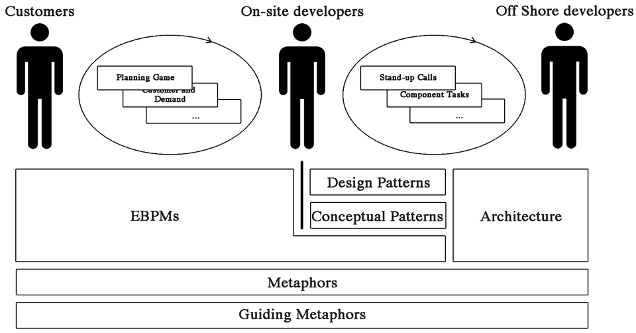

2. Metaphors and patterns. The communication between onshore and offshore developers in the specific case was frequent but not precise. To improve communication between all parties of the project the dual-shore model suggests using metaphors, guiding metaphors, conceptual patterns and design patterns. By using these tools, onshore developers can communicate specifications and changes more efficiently to offshore developers.
3. Online start-up meeting. APPbility staff expressed communication of the basic project features and specifications to offshore developers as a problem.
The dual-shore approach suggests that the onshore and offshore developers start out by meeting physically, and the project is presented by the onshore developers.
The offshore developers will return to their home country with a frame of reference common to onshore developers and the customers. However, this solution is considered relatively expensive for small and low-budget software development. Instead, it is suggested that the start-up meeting is conducted online using video calls and file sharing services. Using experimental forms of online interaction and social confrontations in line with the general momentum of virtual social interactions known from social media and virtual communities of practice [39][40][43].
If the communication relies on EBPMs and the communication tools described in the dual-shore model, it is assessed as possible to establish a common frame of reference through an online meeting. Communication of the basic project features is followingly done efficiently, accurately and without any traveling cost. Establishment of an online social context is in line with [5][4][27] but more emergent and balance the interpersonality with the product-centric exchange of perceptions and positions.

5.3 Project coherency
The purpose of this paper has been to extend the understanding of the applicability of the dual-shore method to overcome onshore-offshore communication discrepancies and make offshoring more successful in low-budget development. A secondary purpose of this paper has been to apply the autoethnographic approach to the offshoring process. This was done by creating a company and engaging the group of authors in the experimentally inspired process improvement with the company. The research-supported practice orientation strongly supports the process of learning of offshoring of agile software development. In this way, the actor self of the autoethnography incites constant reflection on the actual project level and, in particular, on the process improvement level. In this view, the suggestions and findings should be sensible in similar contexts with appropriate reservations for differences of project complexity and maturity of the three parties.
6 Conclusions and suggestions for further work
This study has shown distinct patterns in optimising agile software development in an offshore setting. In addition, it has elaborated the possible pitfalls in this process and introduced the dual-shore approach for management of critical challenges. Furthermore, this article has highlighted the topic by analysing and discussing an autoethnographic methodology distinctively aimed at testing offshoring methodologies and subsequent learning. In addition, the paper has shown how to apply the theory and the dual-shore approach in practice by proposing three specific suggestions for improvements in the ethnographic case study, and describing how to refine the dual-shore model to fit future low-budget agile offshoring software development projects. We conclude that the extended sharing of information as explaining in suggestion 1 on EBPM together with knowledge elements of suggestion 2 and the organisational processes of suggestion 3 together forms a more efficient process without sacrificing the advantages of the agile approach.
Future work is related to implementing the suggested tools from the dual-shore approach into new offshoring projects for APPbility as well as to investigate if the suggestions from the discussion section lead to expected improvements. Furthermore, the company is testing the revised dual-shore approach on other offshoring projects with different contestants.
The findings of this article are the result of the focus imposed on the literature research. The theory found and used in this article revolves around common challenges affecting offshoring of agile software development. However, theory about rare but extensive challenges could also have been reviewed giving a more in-depth overview of what to be aware of.
The dual-shore approach has been used as a solution to common challenges in agile offshoring projects and as a test of Kornstädt and Sauer’s [9] suggestions. However, the theory of this article does not cover other possible tools/methods for overcoming these difficulties. Better and more versatile approaches that could be helpful in overcoming mentioned difficulties might be available.
Moreover, the study does not contain the view of the customer nor the offshore developer which is an important source of error. It contributes to the problem of the autoethnographic study where the researchers are also the researched object and can be biased because of their involvement in the project.
Furthermore, the autoethnographic study is not supplemented with other studies to support its validation and make it applicable on a broader range of practices.
The philosophical world view of this article may result in certain conclusions and preclude others. It can therefore not be excluded that another world view could have led to other findings in this study.
References
1. Sharp, J.H., Ryan, S.D.: Global agile team configuration. Journal of Strategic Innovation and Sustainability 7(1), 120-134 (2011)
2. Kussmaul, C., Jack, R., Sponsler, B.: Outsourcing and offshoring with agility: A case study. Extreme Programming and Agile Methods. In: Zannier, C. et al. (eds): XP/Agile Universe 147-154. Springer, Heidelberg (2004)
3. Lee, S., Yong, H.S.: Distributed agile: Project management in a global environment. Empirical Software Engineering, 15(2), 204-217 (2010)
4. Persson, J.S., Mathiassen, L., Aaen, I.: Agile distributed software development: Enacting control through media and context. Information Systems Journal 22, 411-433 (2012)
5. Sauer, J.: Agile practices in offshore outsourcing–an analysis of published experiences. Proceedings of the 29th IRIS Seminar, Helsingør, Denmark (2006)
6. Anderson, L.: Analytic autoethnography. Journal of Contemporary Ethnography 35(4), 373-395 (2006)
7. Bryman, A., Bell, E.: Business research methods. Oxford Univ. Press, Oxford, UK (2007)
8. Agile Alliance: Manifesto for agile software development. Retrieved 11/29, 2012, from http://www.agilealliance.org/ (2012)
9. Kornstädt, A., Sauer, J.: Mastering dual-shore Development–The tools and materials approach adapted to agile offshoring. In: Meyer, B., Joseph, M. (eds): SEAFOOD - Software Engineering Approaches for Offshore and Outsourced Development, LNCS 4716, pp. 83–95. Springer, Heidelberg (2007)
10. Ambler, S.: Agile modelling: Effective practices for eXtreme Programming and the Unified Process. Wiley, New York (2002)
11. Brown, S.L., Eisenhardt, K.M.: Product development: Past research, present findings, and future directions. Academy of Management Review 20(2), 343-378 (1995)
12. Imai, K., Nonaka, I., Takeuchi, H.: Managing the new product development process: How japanese companies learn and unlearn. Harvard Business School. (1984)
13. Quinn, J. B.: Managing innovation: Controlled chaos. HBR 63(3), 73-84 (1985)
14. Takeuchi, H., Nonaka, I.: The new new product development game. Harvard Business Review 64(1), 137-146 (1986)
15. Erickson, J., Lyytinen, K., Siau, K.: Agile modeling, agile software development, and extreme programming. J. of Database Management 16(4), 88-100 (2005)
16. Dybå, T., Dingsøyr, T.: Empirical studies of agile software development: A systematic review. Information and Software Technology 50(9), 833-859 (2008)
17. Sommerville, I.: Software engineering 8. Pearson, Harlow (2004)
18. Schilling, M.A.: Strategic management of technological innovation, 4ed. McGraw-Hill (2012)
19. Brooks, F.P.: The mythical man-month: Essays on software engineering. Addison-Wesley (1995)
20. Forward, A., Lethbridge, T.C.: The relevance of software documentation, tools and technologies: A survey. Proc. ACM Symposium on Document Engineering, 26-33 (2002)
21. Paetsch, F., Eberlein, A., Maurer, F.: Requirements engineering and agile software development. Enabling Technologies: Infrastructure for Collaborative Enterprises, WET ICE 2003. Proceedings. Twelfth IEEE International Workshops On, 308-313 (2003)
22. Ceschi, M., Sillitti, A., Succi, G., De Panfilis, S.: Project management in plan-based and agile companies. Software, IEEE, 22(3), 21-27 (2005)
23. Det Strategiske Forskningsråd. Erhvervslivets forskning, udvikling og offshoring. http://www.fi.dk/publikationer/2011/analyserapport-erhvervslivets-forskning-udvikling-og-offshoring/hovedbudskaber-fou-offshoring-analyse-13-maj.pdf (2011)
24. Tambo, T., Olsen, M.: Offshoring – the new dilemma of IS research. Proceedings of 33rd IRIS Seminar, Rebild, Denmark (2010)
25. Simons, M.: Distributed agile development and the death of distance. Cutter Consortium Executive Report, Sourcing and Vendor Relationships (2004)
26. Braithwaite, K., Joyce, T.: XP expanded: Distributed extreme programming. Extreme Programming and Agile Processes in Software Engineering, 1524-1526 (2005)
27. Holmström, H., Fitzgerald, B., Ågerfalk, P.J., Conchúir, E.Ó.: Agile practices reduce distance in global software development. Inf. Sys. Management, 23(3), 7-18 (2006)
28. Simons, M.: Internationally agile. Inform IT, 15. March (2002)
29. Martin, A., Biddle, R., Noble, J.: When XP met outsourcing. Extreme Programming and Agile Processes in Software Engineering 51-59 (2004)
30. Batra, D.: Modified agile practices for outsourced software projects. Communications of the ACM 52(9), 143 (2009)
31. Züllighoven, H., Beeger, R.F.: Object-oriented construction handbook: Developing application-oriented software. Morgan Kaufmann, San Francisco (2004)
32. Avison, D., Banks, P.: Cross-cultural (mis) communication in IS offshoring: Understanding through conversation analysis. Journal of Information Technology 23(4), 249-268 (2008)
33. Ramesh, B., Cao, L., Mohan, K., Xu, P.: Can distributed software development be agile? Communications of the ACM 49(10), 41 (2006)
34. Breitling, H., Kornstädt, A., Sauer, J.: Design Rationale in Exemplary Business Process Modeling. In: Dutoit, A.H. et al. (eds.) Rationale Management in Software Engineering, pp. 191-208. Springer, Heidelberg (2006)
35. Crotty, M.: The foundations of social research: Meaning and perspective in the research process. Sage Publications (1998)
36. Kim, B.: Social constructivism. In Orey, M. (ed): Emerging Perspectives on Learning, Teaching, and Technology (2001)
37. Creswell, J.W.: Research design: Qualitative, quantitative and mixed methods approaches. Sage Publications (2008)
38. Hyde, K.F.: Recognising deductive processes in qualitative research. Qualitative Market Research: An International Journal 3(2), 82-90 (2000)
39.Dubé, L., Bourhis, A., Réal, J.: The impact of structuring characteristics on the launching of virtual communities of practice. Journal of Org. Change Mgmt. 18(2), 145-166. (2005)
40.Spaulding, T.J.: How can virtual communities create value for business? Electronic Commerce Research and Applications 9, 38–49 (2010)
41.Dingsøyr, T., Nerur, S., Balijepally, V., Moe, N.: A decade of agile methodologies: Towards explaining agile software development. The Journal of Systems and Software 85, 1213– 1221 (2012)
42.Estler, H.C. et al.: Agile vs. Structured Distributed Software Development: A Case Study. 2012 IEEE Seventh International Conference on Global Software Engineering 11–20 (2012)
43.Dorairaj, S., Noble, J., Malik, P.: Understanding Team Dynamics in Distributed Agile Software Development. Agile Processes in Software Engineering and Extreme Programming, 13th International Conference, XP 2012, Malmo, Sweden, (2012)

