Explainable AI to improve treatment of patients suffering from severe respiratory disorders with mechanical ventilators

Patients that suffer from severe respiratory disorders need to get special respiration support to increase the oxigen saturation of the blood. This is typically done through mechanical ventilators which are supposed to support the patient during inhaling as well as the exhaling.

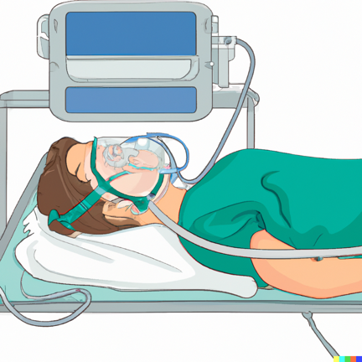
Generated by Dall-E 2

Unfortunately, there are many sources of problems (like wrong mask size, leaks, that result in imperfect patient support and might lead the patient to not using the mask. To personalize the mask and the ventilation support these sources of problems need to be identified. For this, the ventilators can be used, because they contain several sensors for respiratory signals and detect for example sleep apnea events. The monitoring data is also useful to understand how well the mechanical ventilator is personalized for the particular patient and how this might be improved.

The analysis of the monitoring data from mechanical ventilators is done by a human expert and rather cumbersome. Therefore, researchers at Ifi and the Department of Pulmonary Diseases at Oslo University Hospital (OUS) collaborate to investigate the use of explainable AI (xAI) to automatically analyze the monitoring data.

It is well known that AI is “data hungry” and that is a problem for medical events that should be detected and occur very seldom (seen from AI perspective). Therefore, a simulation bench has been set up at (OUS). This includes the following components:
- Lung simulator ASL 5000: this device receives as input a mathematic model of the breathing of patients and generates out of this physical airflow corresponding to the model.
- Artificial throat: the air from the ASL 5000 flow through the artificial throat which can be used to simulate obstructions and other events. On the output from the artificial throat mask leaks can be simulated.
- Mask and mechanical ventilator: state of the art mechanical ventilators are connected with the mask to the output of the artificial throat.

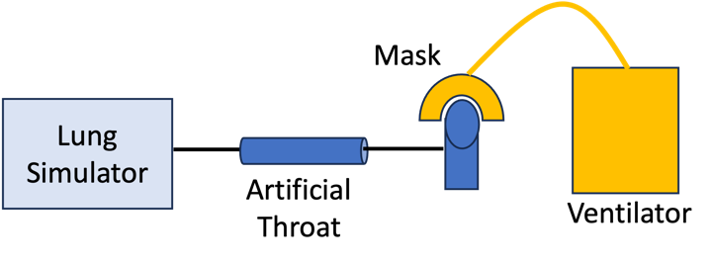
Figure 1: Basic set-up of simulation bench
With this set-up it is possible to generate all those events of interest in large numbers in order to train proper AI models.

There are several research topics for Master Theses in this context that are related to:
- Systematic data generation
- Data quality quantification
- Extensible data pipeline from mechanical ventilator to structured data storage
- Explainable AI
- Uncertainty quantification

If you are interested please get in touch with us:
- Thomas Plagemann, plageman@ifi.uio.no, room 9161
- Farzan Majeed Nori, farzanmn@ifi.uio.no, room 9160
- Ingrid Chieh Yu ????

