Delete everything in yellow when SOP is written.
This template can be used to write a Standard Operation Procedure (SOP), a Safe Job Analysis (SJA) or both in one document. A stand-alone SOP, for example, can describe how to use an instrument. A standalone SJA assesses, for example, safe handling, storage and waste disposal of a chemical. A SOP with SJA might be the step-by-step description of a standard experiment including risk assessment of each step.
An stand-alone SOP consist at minimum of section 1., 6. and (9.)
A stand-alone SJA will consist at least of SOP Section 1., 2., 3., 4., 5., 7., 8. and (9.).
Delete sections not relevant for the type of document you are writing.
You should add sections as needed, such as “special precautions” and “emergency procedures” for particularly dangerous chemicals (examples: working with cyanides, pyrophoric chemicals, NaN3, HF).

INTRODUCTION/PURPOSE
Describe briefly what this SOP/SJA is about

responsibilities and SAFETY
The general responsibility for HSE at the Department of Chemistry lies with the Head of the Department. However, the room responsible person must have control and knowledge of all ongoing activities that take place in space, ensure that activities follow established procedures, and provide adequate labelling of laboratory chemicals. For more details on responsibility, see KI’s HSE manual.
See the general UiO procedure Risk management policy in laboratories for an overview of responsibilities at UiO.

General laboratory safety applies. For more information, see KI’s HSE manual.
Laboratory users are obliged to follow established HSE procedures including this SOP/SJA when carrying out the work described in this SOP/SJA

NECESSARY SAFETY EQUIPMENT
List all necessary safety equipment, could also include dust mask, hearing protection, tc.

Fume hood

Chemical and Biological Hazard
List chemicals used in this procedure and include hazard symbols H and P-phrases. Include chemicals in the risk assessment (point 7.)

4.1 Chemicals

2-Mercaptoethanol  M3148 from Sigma Aldrich (MSDS)  CAS no: 60-24-2  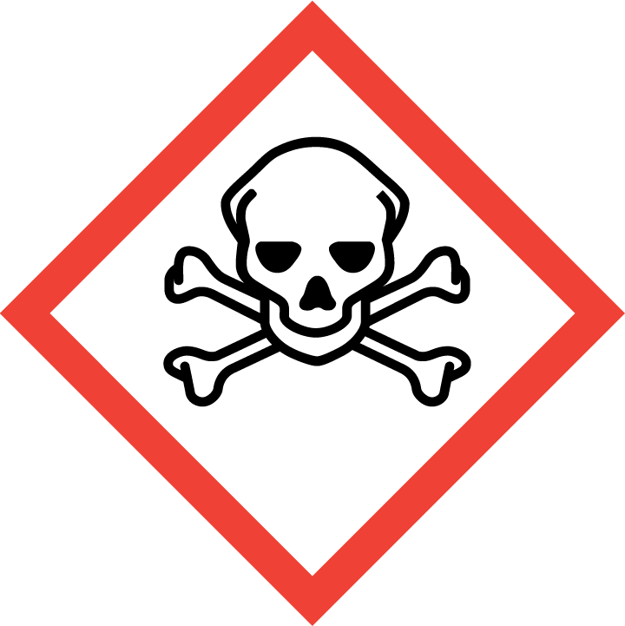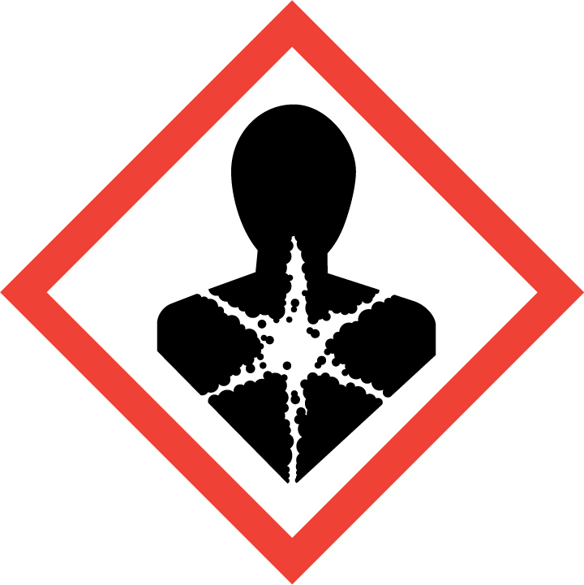  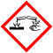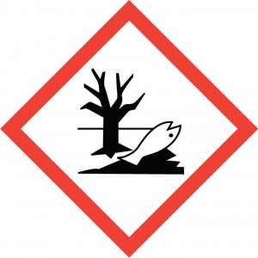 | H301 + H331: Toxic if swallowed or if inhaled  H310: Fatal in contact with skin.  H315: Causes skin irritation.  H317 May cause an allergic skin reaction.  H318 Causes serious eye damage.  H373 May cause damage to organs (Liver, Heart) through prolonged or repeated exposure if swallowed.  H410 Very toxic to aquatic life with long lasting effects.  P261: Avoid breathing vapours.  P273: Avoid release to the environment.  P280: Wear protective gloves/ eye protection/ face protection.  IF SWALLOWED: Immediately call a POISON CENTER or doctor/ physician. IF ON SKIN: Gently wash with plenty of soap and water.  IF IN EYES: Rinse cautiously with water for several minutes. Remove contact lenses, if present and easy to do. Continue rinsing.

4.2 Biological Agents

Delete or modify as appropriate

If you are working with biological hazard, you should use this table and information from the PSDS. If not, cut it out.

Biological agent | Laboratory hazards, necessary precautions and emergency planning
Neisseria gonorrheae  Risk Group 2  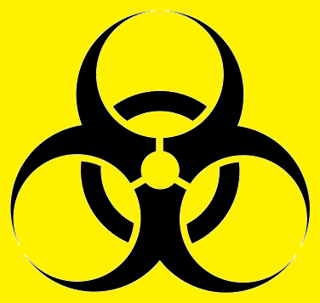 | Containment Level 2 facilities is required  Reported laboratory acquired infections:  - Gonococcal conjunctivitis (eye)  - Cutaneous infections (skin)  The bacteria are mostly known for causing Genital gonorrhoeae.  Wear safety goggles, lab coat and gloves.  Avoid contact with contaminated gloves.  Wash hands after work.  If exposed seek medical assistance.

Special cautions necessary due to reproductive toxicity
Delete or modify as appropriate

Generally, it is not recommended to work with a chemical that has carcinogenic or reproductive effects if you are planning to be or are pregnant. If a chemical is proven to pass into breast milk, it is not recommended to perform the procedure if you are breast-feeding.

If you are working with Class II biological agents that may cause infections, you should consider the risks using the relevant PSDS and other relevant documentation.

Planning pregnancy (men and women): Not recommended to perform this procedure.
Pregnant: Not recommended to perform this procedure.
Breast-feeding: None.

PROCEDURES: Description of procedure
List equipment used and describe the procedure, maybe add pictures or reaction diagrams,…(could be a procedure on how to use an instrument or step-step description of an experiment or preparation of a standard solution,…)

Necessary equipment:
Pipettes
Pipette tips, assorted sizes
Eppendorf tubes (2 and 1,5mL)

Step 1

Step2

…

RISK ASSESSMENT
The likelihood is assessed by assuming the user following the precautions stated in the step-by-step risk assessment (SJA) below.

Risk assessment; step by step

When working with chemicals, always include spill response and consider formation of side products.
Part of procedure |  | Unwanted scenarios | Precautions | Emergency planning | S*K
 | Same points as in the procedure | What can go wrong? | What can be done to prevent. | What precautions are in place to minimize the consequences in the event of an incident | 2*2
 |  |  |  |  | 3*3

Overall risk assessment for this SOP
Risk categories
- Red: S*K=10-25 the overall risk is an unacceptable risk. New precautions to reduce the risk should be established.
- Yellow: S*K=4-9 the overall risk is medium. New precautions to reduce the risk should be considered.
- Green: S*K=1-4 the overall risk is fully acceptable - minimal risk.
If S*K of the step-by-step risk assessment falls into different categories (as listed above), the overall risk is set to the highest S*K value.

When following this SOP, there is MEDIUM risk associated with this procedure, as some S*K values are higher than or equal to 5.

Substitution
According to Norwegian law, we have to assess the possibility of substitution of hazardous chemicals that fall under the EU REACH Candidate list.
This assessment needs to be documented.

Not significant for this procedure.

WASTE DISPOSAL
Modify and delete as appropriate. Do any chemicals need to be quenched for disposal? Be specific in the description of waste disposal. What waste do you produce?

Waste type | Approx volume | Disposal method | Environmental risk
Contaminated gloves and used disposable equipment | -
Hazardous chemical leftovers
Non-hazardous chemical leftovers
…

REFERENCES

