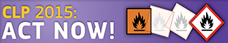

Classification and labelling of aqueous solutions of one substance

Introduction
with exercises

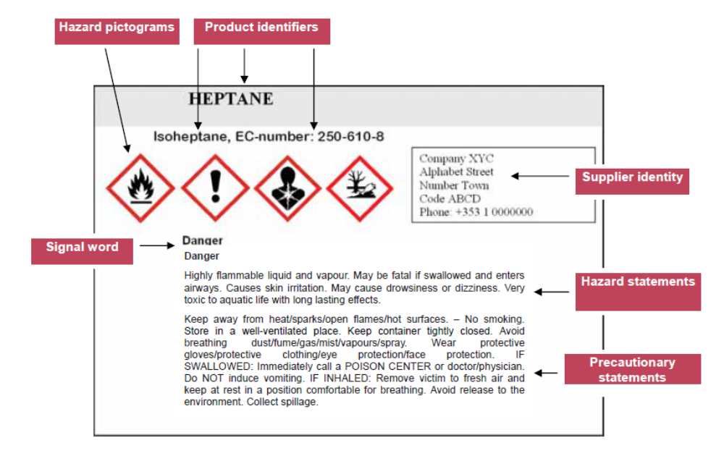

Content

Aims 3
Relevant regulations 3
GHS and CLP 3
CLP in Norway 3
REACH 3
ECHA 3
Labelling 4
Location of information on the CLP hazard label 5
Labelling with only hazard pictogram and signal word 5
Not classified, according to CLP 5
Concepts in CLP 6
Classification and finding label elements 9
Check-list for classifying and making a label 9
Links 9
Exercise 1a: Create a label for 2 mol/L NaOH, in 1 L bottle 10
Exercise 1b (optional): Create a label for 5 mol/L HCOOH, in 1 L bottle (density 1,05 g/mL) 10
Exercise 2a: Create a label for 15 % HCl in 1 L bottle 11
Exercise 2b (optional): Create a label for 7,7 % H₂O₂ in 1 L bottle 11
Exercise 3a: Create a label for 9 % NH₃ in 1 L bottle 12
Exercise 3b (optional): Create a label for 0,3 mol/L HNO₃ in 1 L bottle 12
Exercise 4a: Create a label for 0,2 mol/L CuSO₄ in 1 L bottle 13
Exercise 4b (optional): Create a label for 1 mol/L ZnCl₂ in 1 L bottle 13

Aims
Competence aims
The aims of the seminar are to enable students to:
- Be aware of the regulations that apply to classification and labelling of chemicals
- Explain some fundamental concepts used in classification and labelling of hazardous substances and mixtures
- Explain the elements of CLP hazard labelling
- Label aquatic solutions of 2 mol/L NaOH, 15 % HCl, 9 % NH₃ and 0,2 mol/L CuSO₄

Relevant regulations

GHS and CLP
Trade in substances and mixtures is not only an issue relating to the internal market, but also to the global market. With a view to facilitating worldwide trade while protecting human health and the environment, harmonised criteria for classification and labelling together with general principles of their application have been carefully developed over a period of 12 years within the United Nations (UN) structure. The result was called the Globally Harmonised System of Classification and Labelling of Chemicals (UN GHS: http://www.unece.org/trans/danger/publi/ghs/ghs_welcome_e.html ).
The GHS has been implemented in the EU by the CLP Regulation. The CLP Regulation is legally binding across the Member States (and Norway). It is directly applicable to industry. The hazard of a substance or mixture is the potential for that substance or mixture to cause harm. It depends on the intrinsic properties of the substance or mixture. Hazard labelling allows for the communication of hazard classification to the user of a substance or mixture, to alert the user to the presence of a hazard and the need to avoid exposures and the resulting risks. CLP sets general packaging standards, in order to ensure the safe supply of hazardous substances and mixtures.

CLP in Norway
Forskrift om klassifisering, merking og emballering av stoffer og stoffblandinger (CLP) in force in Norway from 16. June 2012, replacing Forskrift om klassifisering, merking mv. av farlige kjemikalier (Merkeforskriften) after 1. June 2015.

REACH
REACH is the Regulation on Registration, Evaluation, Authorization and Restriction of Chemicals. It entered into force on 1st June 2007. It streamlines and improves the former legislative framework on chemicals of the European Union (EU).

ECHA
The European Chemicals Agency (ECHA) is a Community body which was established for the purpose of managing REACH. It is central to the implementation of both REACH and CLP, to ensure consistency across the EU.

Labelling

Sodium hydroxide 1 mol/L NaOH
4 % NaOH, CAS no. 1310-73-2
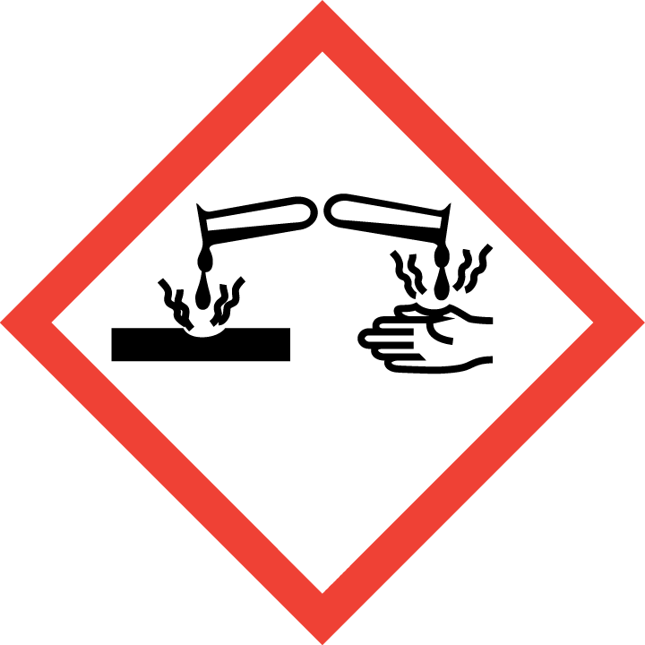
Danger

Causes severe skin burns and eye damage.

Wear eye protection. IF ON SKIN (or hair): Take off immediately all contaminated clothing. Rinse skin with water. IF IN EYES: Rinse cautiously with water for several minutes. Remove contact lenses, if present and easy to do. Continue rinsing. Immediately call a POISON CENTER.

Company’s name , adress and telephone number:

(Made by, date)
Hazard statement
Product identifier
Hazard pictogram
Signal word
Precautionary statements

Company’s identity
Supplemental labelling information

CLP requires the label to be written in the official language, additional languages may be used.

Location of information on the CLP hazard label
The hazard pictograms, signal word, hazard statements and precautionary statements shall be kept together on the label.
Hazard statements shall be grouped together on the label while the order of the hazard statements can be chosen freely.
Precautionary statements shall be grouped together on the label while the order of the precautionary statements can be chosen freely.
In case more than one language is used on the label, the hazard and precautionary statements of the same language shall be grouped together on the label.
Any supplemental information as referred to in CLP Article 25 shall be included in the section for supplemental labelling and placed alongside the label elements referred to in CLP Article 17(1)(a)– (g).

Labelling with only hazard pictogram and signal word
Exeptions where the contents do not exceed 125 ml
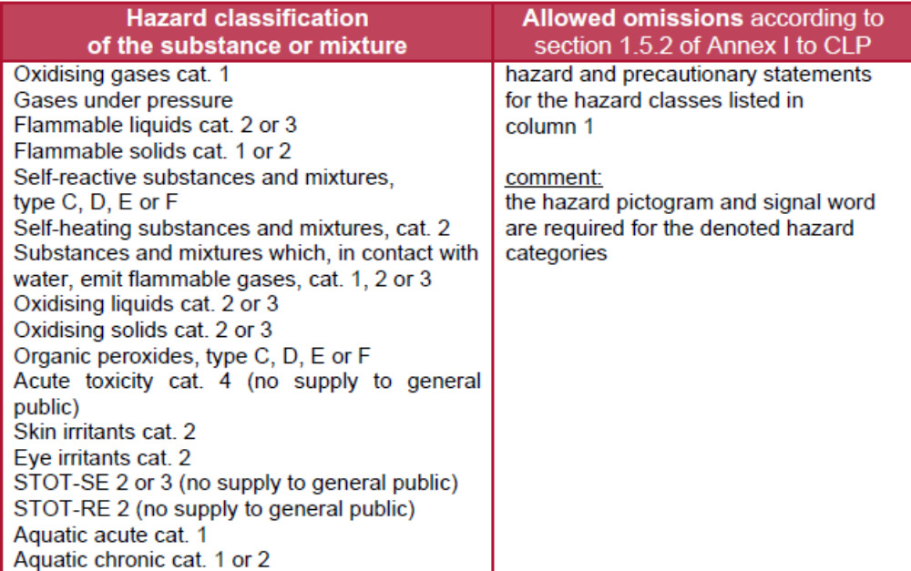

Not classified, according to CLP
Bottles with mixtures that are not classified as hazardous may be labelled “Not classified, according to CLP” for obvious reasons.

Concepts in CLP
Hazardous substances and mixtures
All substances and mixtures meeting the criteria of one or more of the hazard classes in CLP are considered hazardous.
CLP hazard classes and categories
There are three groups of hazard classes: Physical hazards, Health hazards, Environmental hazards
Categories: Category 1A, 1B, and 1C, Category 2, Category 3 and Category 4:

Leaflet with all hazard classes and categories,
in English: CLP poster
in Norwegian: CLP plakat

Product identifier
A name and an identification number as they appear in the Classification and Labelling Inventory.
Hazard pictograms
http://www.unece.org/trans/danger/publi/ghs/pictograms.html

Signal words
CLP introduces the two UN GHS signal words ‘Danger’ (Fare) and ‘Warning’ (Advarsel) to indicate the severity of a hazard.
Where you have to use the signal word “Danger”, the signal word “Warning” shall not appear on the label.
Hazard statements
Oversikt fra Miljødirektoratet (in English and Norwegian)
Code ranges of hazard statements under CLP
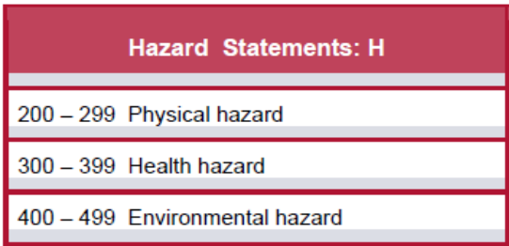

Precautionary statements
Oversikt fra Miljødirektoratet (in English and Norwegian)
Code ranges of precautionary statements under CLP
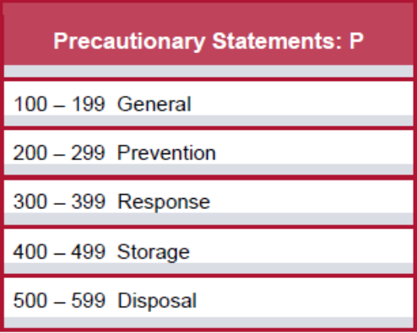

CAS-number Chemical Abstract Service number, identification number

ATE Acute Toxicity Estimate
M-factor:
M-factor means a multiplying factor. It is applied to the concentration of a substance classified as hazardous to the aquatic environment acute category 1 or chronic category 1, and is used to derive by the summation method the classification of a mixture in which the substance is present.

C&L Inventory
The classifications of all substances notified or registered under REACH or CLP will be included in the Classification and Labelling Inventory established at ECHA (CLP Article 42). The inventory will indicate whether a classification is harmonised or whether it has been agreed between two or more notifiers or registrants.
Capacity of the package Dimensions of the label)
Sizes
Label: ≤ 3 liters. If possible, at least 52 mm x 74 mm

Pictogram: If possible, at least 16 mm x 16 mm.

Each hazard pictogram shall cover at least one fifteenth of the minimum surface area of the label dedicated to CLP information, but the minimum area shall not be less than 1 cm².

16 mm x 16 mm pictograms
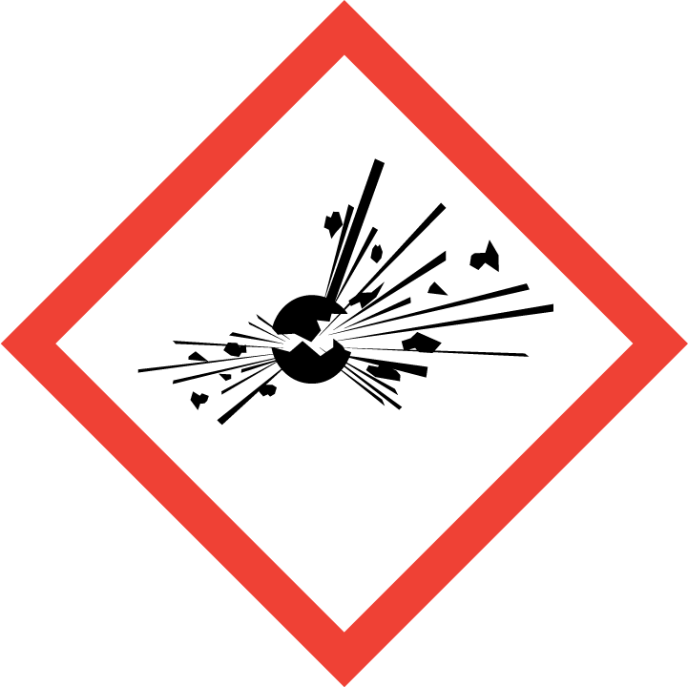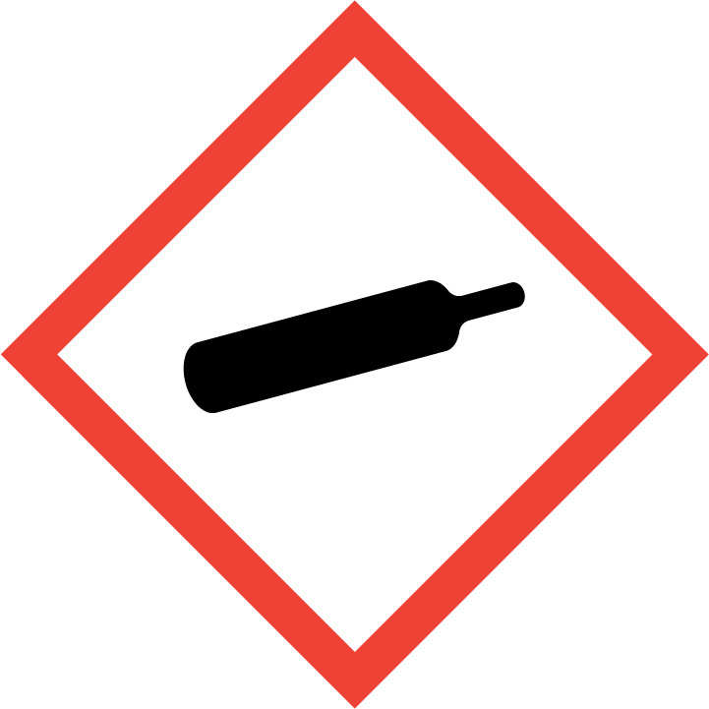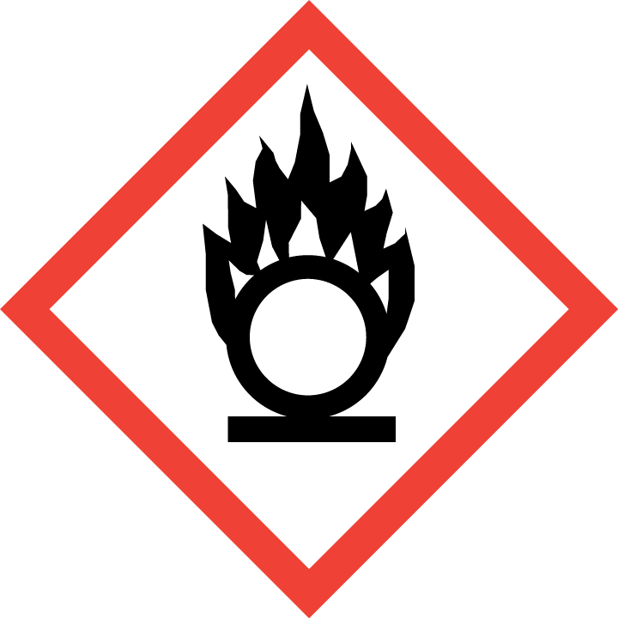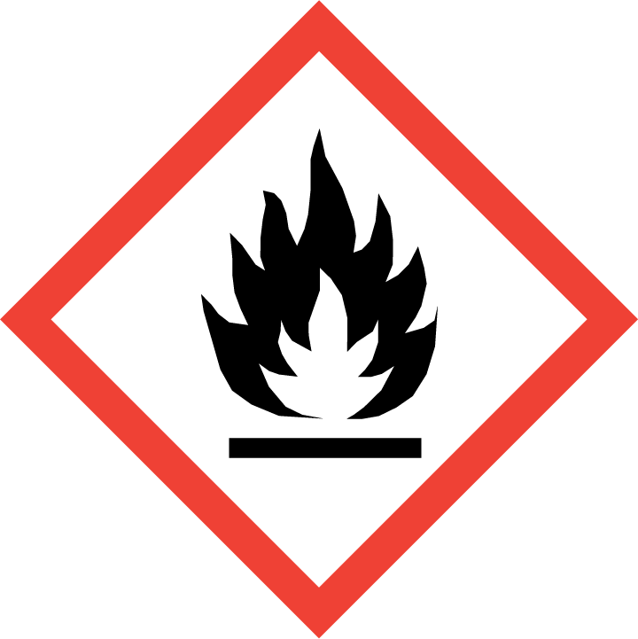
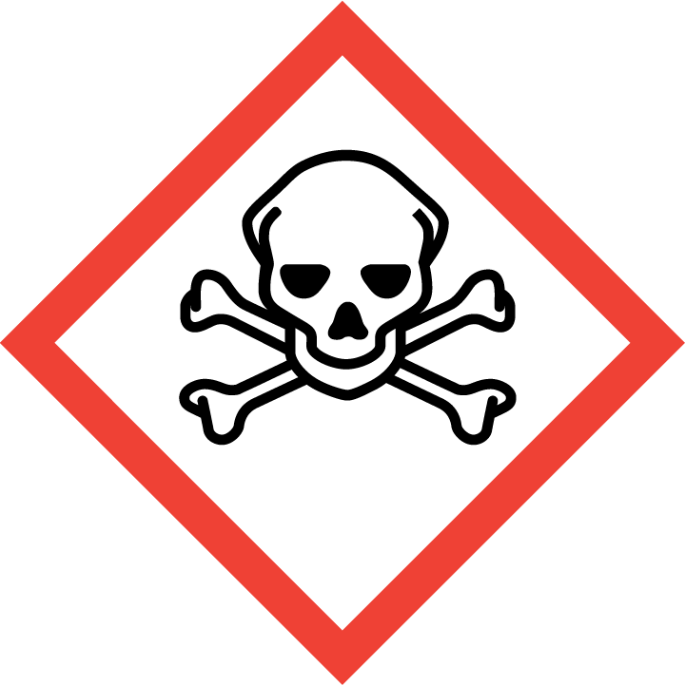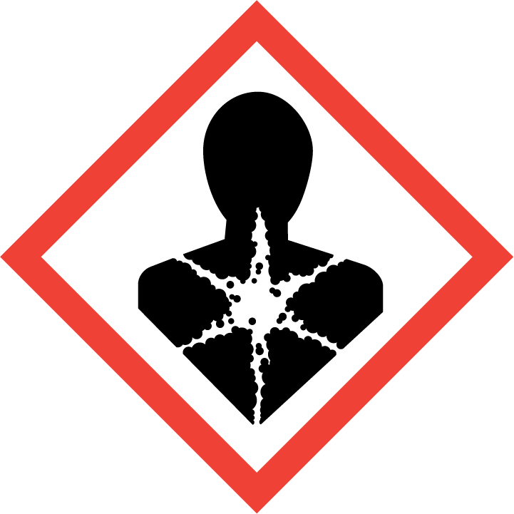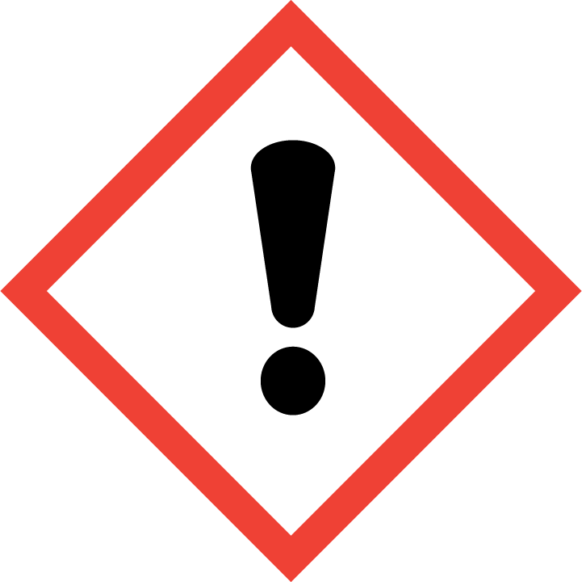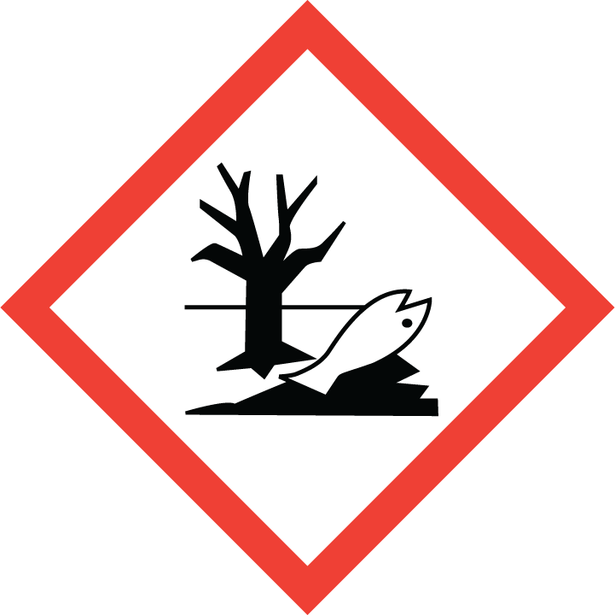

10 mm x 10 mm pictograms

Classification and finding label elements

Checklist for classifying and making a label

- Find numerical identifier (wikipedia)
- Calculate approx. concentration in % (m/m)
- Classify your solution
  - Specific concentration limits (C&L inventory)
  - For hazard classes without specific concentration limits use Generic concentration limits (CLP – regulation)
- Find hazard pictogram(s), signal word and hazard statement(s) for all the hazard classes in your classification (CLP poster)
- Choose precautionary statements (Guidance on labelling and packaging in accordance with Regulation (EC) No 1272/2008). Norwegian translation (Sikkerhetssetningene fra miljødirektoratet)
- Add company identity and supplemental information.

Links

C&L inventory
CLP poster (Norwegian) (English)
CLP regulation (Norwegian) (English)
Guidance on labelling and packaging in accordance with Regulation (EC) No 1272/2008
Sikkerhetssetningene fra Miljødirektoratet
SDS Ammonia
SDS Copper(II)sulfate

Exercise 1a: Create a label for 2 mol/L NaOH, in 1 L bottle

- Use wikipedia to find the numerical identifier for sodium hydroxide.
- Calculate the mass percentage of NaOH in your solution (you need this to classify the solution).
- Go to C&L Inventory to classify your solution.
  - Hit “I have read and....”, after this you might have to refresh the page.
  - Hit “CL Inventory” in the middle of the page.
  - Write the name (substance Name), in English: sodium hydroxide or CAS-number for the substance (numerical identifier).
  - Hit “Search”.
  - You now get a list in the bottom of the page. Click on the “eye” symbol on the right side, in the row, which has the name of your substance.
- In table 3 CLP Classification, the first column states the classification of the pure substance. Use the “Specific Concentration limits” and classify your solution.
- Use the CLP poster to find the labelling elements for your solution (hazard pictogram(s), signal word and hazard statement(s))
All hazard statements resulting from the classification shall appear on the label. The label must be written in the national language.
- Precautionary statements:
You can find precautionary statements in chapter 7 of Guidance on labelling and packaging in accordance with Regulation (EC) No 1272/2008. There you will also find guidance on how to select precautionary statements. Normally, not more than six precautionary statements shall appear on the label, unless necessary to reflect the nature and the severity of the hazards. Any selection shall take into account the hazard statements used, and the intended use or uses of the mixture. Precautionary statements with + between them, shall appear together. The wording of the precautionary statements in Norwegian should be taken as stated in Sikkerhetssetningene fra Miljødirektoratet.

Exercise 1b (optional): Create a label for 5 mol/L HCOOH, in 1 L bottle (density 1,05 g/mL)

Exercise 2a: Create a label for 15 % HCl in 1 L bottle

- Use wikipedia to find the numerical identifier for hydrochloric acid.
- Go to C&L Inventory to classify your solution.
  - Hit “CL Inventory” in the middle of the page.
  - Write the substance name: hydrochloric acid or CAS-number (numerical identifier).
  - Hit «Search”
  - You now get a list in the bottom of the page. Click on the eye symbol on the right side, in the row, which has the name “hydrochloric acid…%”.
- In table 3.1 CLP Classification, the first column states the classification of a saturated solution. See Specific Concentration limits and classify your solution for every hazard class.
- Use the CLP poster to find the labelling elements for the solution.
- Precautionary statements:
Use the Guidance on labelling and packaging in accordance with Regulation (EC) No 1272/2008 and choose precautionary statements.

Exercise 2b (optional): Create a label for 7,7 % H₂O₂ in 1 L bottle

Exercise 3a: Create a label for 9 % NH₃ in 1 L bottle

- Use wikipedia to find the numerical identifier for ammonia.
- Go to C&L Inventory to classify the solution.
  - Hit “CL Inventory” in the middle of the page.
  - Write the substance name: ammonia or CAS-number (numerical identifier).
  - Hit “Search”
  - You now get a list in the bottom of the page. Click on the eye symbol on the right side, in the row, which is relevant for your substance.
- In table 3.1 CLP Classification, the first column states the classification of the saturated solution. See Specific Concentration limits and find the classification for your mixture in every hazard class.
- For the two hazard classes without specific concentration limits, you must use generic concentration limits to decide if and how the 9 % ammonia solution should be classified.
  - (Skin corr 1B) Use table 3.2.3 in the CLP regulation.
  - (Aquatic acute 1) Use the lowest LC₅₀ or EC₅₀ - value found in chapter 12 of the safety data sheet for ammonia, and tables 4.1.3 and 4.1.1 in the CLP regulation.
- Use the CLP poster to find the labelling elements (pictogram(s), signal word and hazard statement(s)).
- Precautionary statements:
Use the Guidance on labelling and packaging in accordance with Regulation (EC) No 1272/2008 and choose precautionary statements.

Exercise 3b (optional): Create a label for 0,3 mol/L HNO₃ in 1 L bottle

Exercise 4a: Create a label for 0,2 mol/L CuSO₄ in 1 L bottle

- Use English Wikipedia to find the numerical identifier for copper(II)sulfate.
- Go to C&L Inventory to classify the solution.
  - Hit “CL Inventory” in the middle of the page.
  - Write the substance name: copper(II)sulfate or CAS-number (numerical identifier)
  - Hit «Search”
  - You now get a list in the bottom of the page. Click on the eye symbol on the right side, in the row, which is relevant for your substance.
- Check for Specific Concentration limits.
- For hazard classes without specific concentration limits, you must use other information to decide if and how the 0,2 mol/L copper(II)sulfate solution should be classified.
  - (Skin irrit. 2) Use table 3.2.3 in the CLP regulation.
  - (Eye irrit. 2) Use table 3.3.3 in the CLP regulation.
  - (Aquatic acute 1) Use the lowest LC₅₀ or EC₅₀ - value found in chapter 12 of the safety data sheet for copper(II)sulfate and tables 4.1.3 and 4.1.1 in the CLP regulation.
  - (Aquatic chronic 1) Use the lowest LC₅₀ or EC₅₀ - value found in chapter 12 of the safety data sheet for copper(II)sulfate, and tables 4.1.3 and 4.1.2 in the CLP regulation.
  - (Acute tox. 4) Use table 3.1.1 and 3.1.2 in the CLP regulation and the equation given in 3.1.3.6.1 (also shown below).
$${ATE}_{mix}=\frac{100*ATE}{c}=2000$$

- Precautionary statements:
Use the Guidance on labelling and packaging in accordance with Regulation (EC) No 1272/2008 and choose precautionary statements.

Exercise 4b (optional): Create a label for 1 mol/L ZnCl₂ in 1 L bottle

