Creating labels for diluted solutions for use in chemistry research and education

Exercises

Content

Checklist for creating a label 3
Content on the label 3
Links 4
Pictograms 4
Excercises 5
Exercise 1a: Create a label for 2 mol/L NaOH 5
Exercise 1b Create a label for 2 % formic acid, HCOOH 6
Exercise 2a: Create a label for 0,1 mol/L ZnCl₂ 7
Exercise 2b: Create a label for 2 mol/L ZnSO₄ 7

Checklist for creating a label

- Find numerical identifier
- Calculate approx. concentration in % (m/m)
- Classify your solution
  - Specific concentration limits (ECHA CHEM)
  - For hazard classes without specific concentration limits use Generic concentration limits (CLP – regulation)
- Find hazard pictogram(s), signal word and hazard statement(s) for all the hazard classes in your classification (CLP poster)
- Choose precautionary statements (Guidance on labelling and packaging in accordance with Regulation (EC) No 1272/2008).
- Add supplemental information.

Content on the label

The label should contain the following
Name, concentration, formula
Identification number

Hazard pictogram
Signal word
Hazard statements
Precautionary statements
Supplemental information (made by, date)

Links
ECHA CHEM
CLP poster (norsk)
CLP regulation (norsk)
Guidance on labelling and packaging in accordance with Regulation (EC) No 1272/2008
SDS Zinc chloride
SDS Zinc sulfate

Pictograms

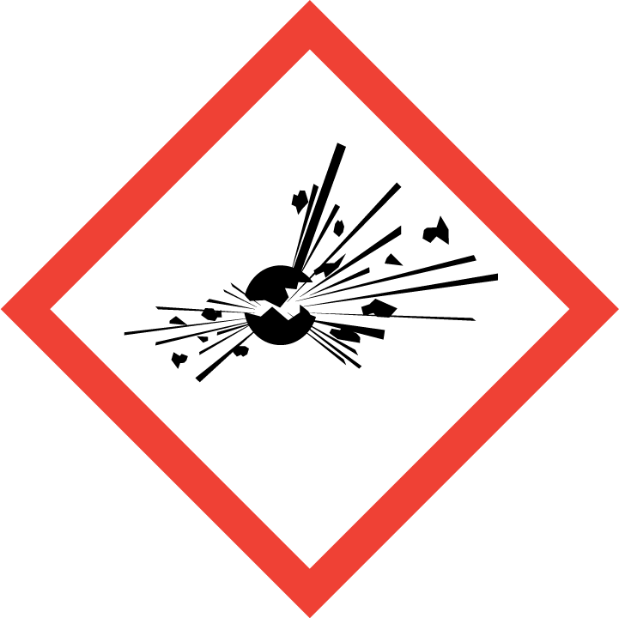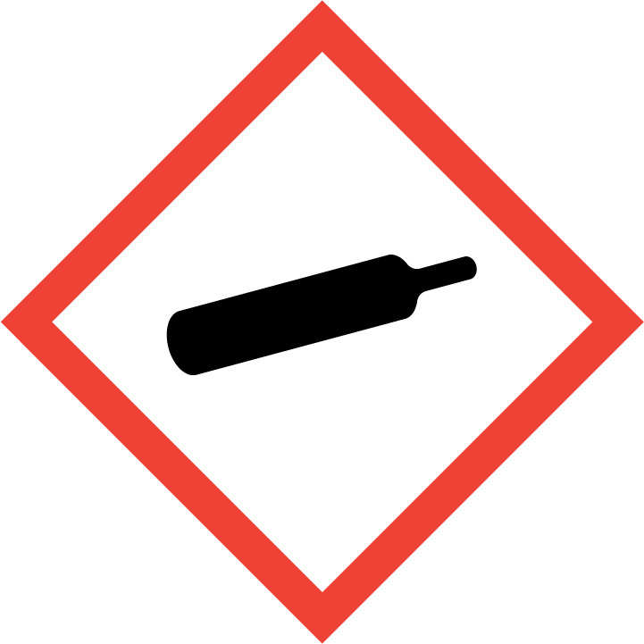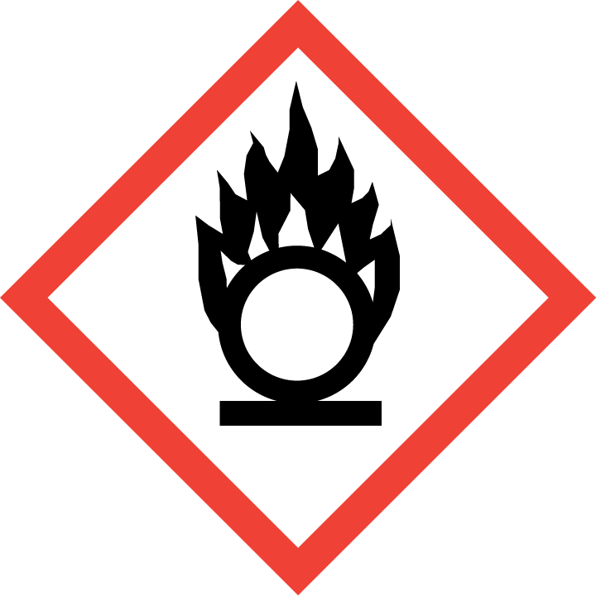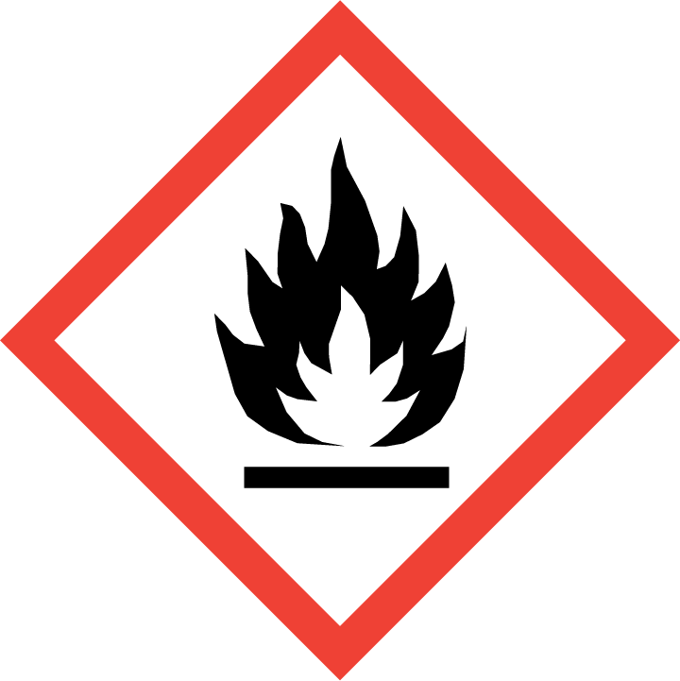
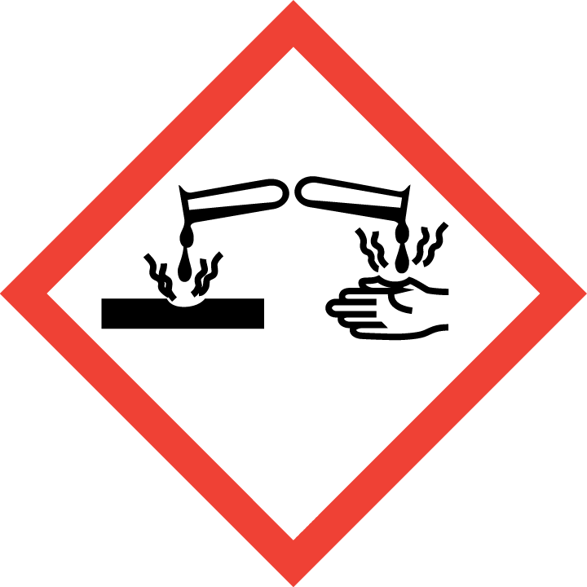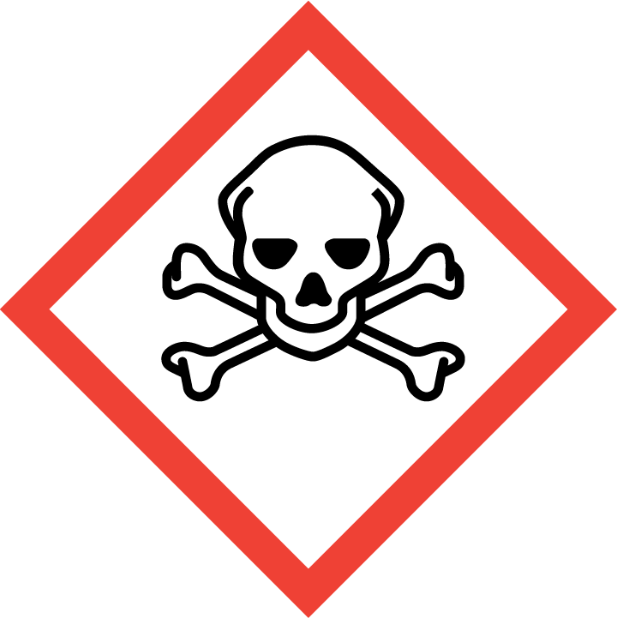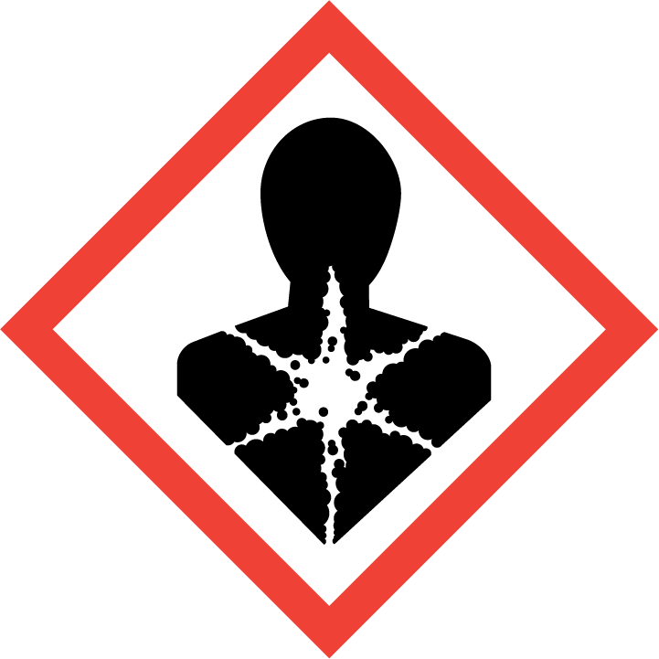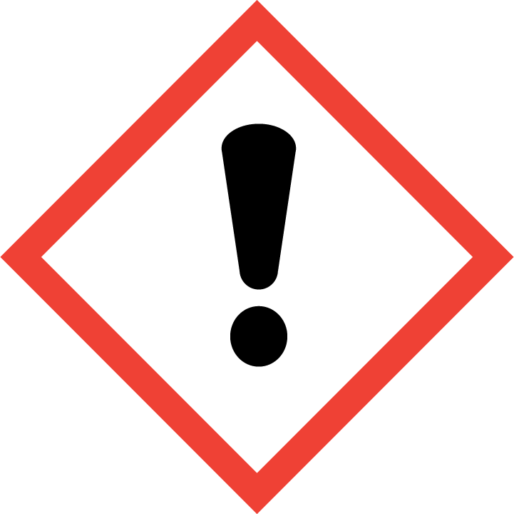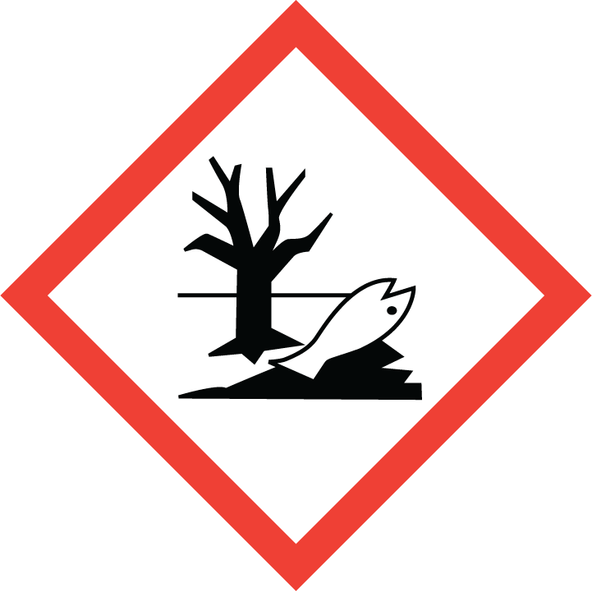

Excercises

Exercise 1a: Create a label for 2 mol/L NaOH

- Use e. g. Wikipedia to find the numerical identifier for sodium hydroxide.
- Calculate the mass percentage of NaOH in your solution (you need this to classify the solution).
- Go to ECHA CHEM to classify your solution.
  - Write the name (substance Name), in English: sodium hydroxide or CAS-number for the substance (numerical identifier).
  - Hit “Search”.
  - Scroll down and hit “Harmonized classifications”.
- Under “Classification” you will see the classification of the pure substance. Scroll down and use the “Specific Concentration limits” to classify your solution.
- Use the CLP poster to find the labelling elements for your solution (hazard pictogram(s), signal word and hazard statement(s)). All hazard statements resulting from the classification shall appear on the label.
- Precautionary statements:
You can find precautionary statements in chapter 7 of Guidance on labelling and packaging in accordance with Regulation (EC) No 1272/2008. There you will also find guidance on how to select precautionary statements. Normally, not more than six precautionary statements shall appear on the label, unless necessary to reflect the nature and the severity of the hazards. Any selection shall consider the hazard statements used, and the intended use or uses of the mixture. Precautionary statements with + between them, shall appear together.

Once you have selected precautionary sentences for one hazard class, you can reuse them on other labels for that hazard class.

Exercise 1b Create a label for 2 % formic acid, HCOOH

- Use Wikipedia to find the numerical identifier for formic acid.
- Go to ECHA CHEM to classify your solution.
  - Write the name or CAS-number for the substance.
  - Hit “Search”.
  - Scroll down and hit “Harmonized classifications”.
- Under “Classification” you will see the classification of the pure substance. Scroll down and use the “Specific Concentration limits” to classify your solution.
- Use the CLP poster to find the labelling elements for the solution (hazard pictogram(s), signal word and hazard statement(s)). All hazard statements resulting from the classification shall appear on the label.
- Precautionary statements:
Use the Guidance on labelling and packaging in accordance with Regulation (EC) No 1272/2008 and choose precautionary statements for each hazard class.

Exercise 2a: Create a label for 0,1 mol/L ZnCl₂

- Use Wikipedia to find the numerical identifier for zinc chloride.
- Go to ECHA CHEM to classify your solution.
  - Write the name or CAS-number for the substance.
  - Hit “Search”.
  - Scroll down and hit “Harmonized classifications”.
- Under “Classification” you will see the classification of the pure substance. Scroll down and use the “Specific Concentration limits” to classify your solution.
- For the hazard classes without specific concentration limits, you must use generic concentration limits to decide if and how the solution should be classified.
  - (Skin corr 1B) Use table 3.2.3 in the CLP regulation.
  - (Aquatic acute 1) Use the lowest LC₅₀ or EC₅₀ - value found in chapter 12 of the safety data sheet for Zinc chloride, and the left side of table 4.1.3 in the CLP regulation to find the M-factor. Then use table and 4.1.1 in the CLP regulation to classify the solution.
  - (Aquatic chronic 1) Use the lowest NOEC value found in chapter 12 of the safety data sheet and the right side of table 4.1.3 in the CLP regulation to find the M-factor. Then use table 4.1.2 to classify the solution. If no NOEC value is listed in the SDS, use the lowest LC₅₀ or EC₅₀ and the left side of table 4.1.3 in the CLP regulation to find the M-factor.
  - (Acute tox. 4) Use the LD 50 /LC 50 where available (section 11 in SDS) or the conversion value from table 3.1.2 (that relates to the classification category) in the CLP regulation to find the ATE of your substance. Then use the equation given in 3.1.3.6.1 in the CLP regulation (also shown below, where c = concentration in mass %) to calculate the ATE of the mixture. Finaly, use table 3.1.2 to find the hazard category of the mixture.
$${ATE}_{mix}=\frac{100*ATE}{c}$$

- Use the CLP poster to find the labelling elements (pictogram(s), signal word and hazard statement(s)).
- Precautionary statements:
For hazard classes that you have already found precautionary statements for other labels – reuse them. Then use the Guidance on labelling and packaging in accordance with Regulation (EC) No 1272/2008 and choose precautionary statements for the rest of the hazard classes.

Exercise 2b: Create a label for 2 mol/L ZnSO₄

