Creating labels for diluted solutions for use in chemistry research and education

Exercises

Content

Checklist for creating a label 3
Content on the label 3
Links 4
Pictograms 4
Excercises 5
Exercise 1a: Create a label for 2 mol/L NaOH 5
Exercise 1b Create a label for 10 % hydrochloric acid, HCl(aq) 6
Exercise 2a: Create a label for 0,1 mol/L ZnCl₂ 7
Exercise 2b: Create a label for 2 mol/L ZnSO₄ 7

Checklist for creating a label

- Find numerical identifier
- Calculate approx. concentration in % (m/m)
- Classify your solution
  - Specific concentration limits (ECHA CHEM)
  - For hazard classes without specific concentration limits use Generic concentration limits (CLP – regulation and also in the PP presentation)
- Find hazard pictogram(s), signal word and hazard statement for all the hazard classes in your classification (Chapter 7 in “Guidance on labelling and packaging in accordance with Regulation (EC) No 1272/2008”)
- Choose precautionary statements (Chapter 7 in “Guidance on labelling and packaging in accordance with Regulation (EC) No 1272/2008”).
- Add supplemental information.

Content on the label

The label should contain the following
Name, concentration, formula
Identification number

Hazard pictogram
Signal word
Hazard statements
Precautionary statements
Supplemental information (made by, date)

Links
ECHA CHEM
CLP regulation (norsk)
Guidance on labelling and packaging in accordance with Regulation (EC) No 1272/2008
SDS Zinc chloride
SDS Zinc sulfate
CLP poster (norsk)

Pictograms

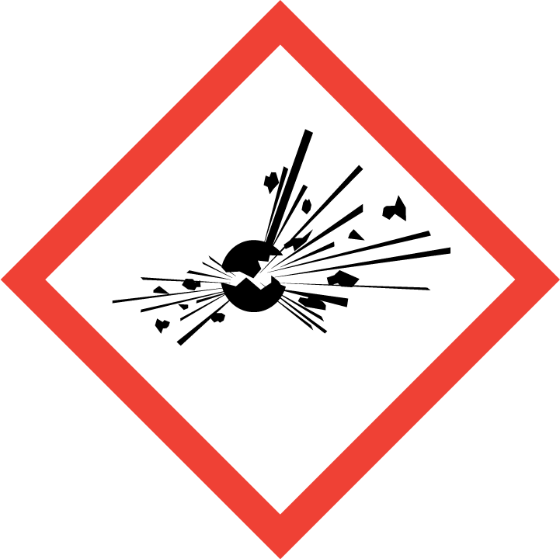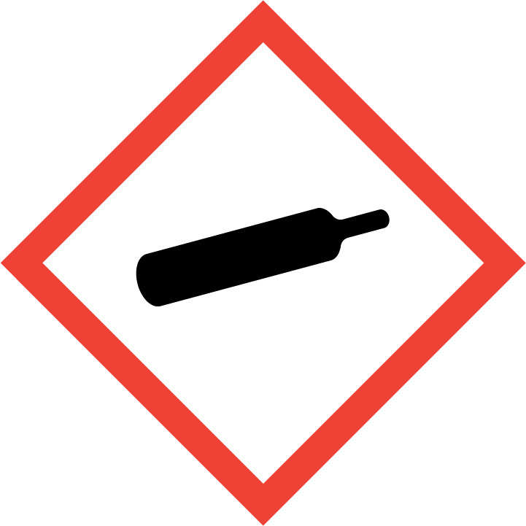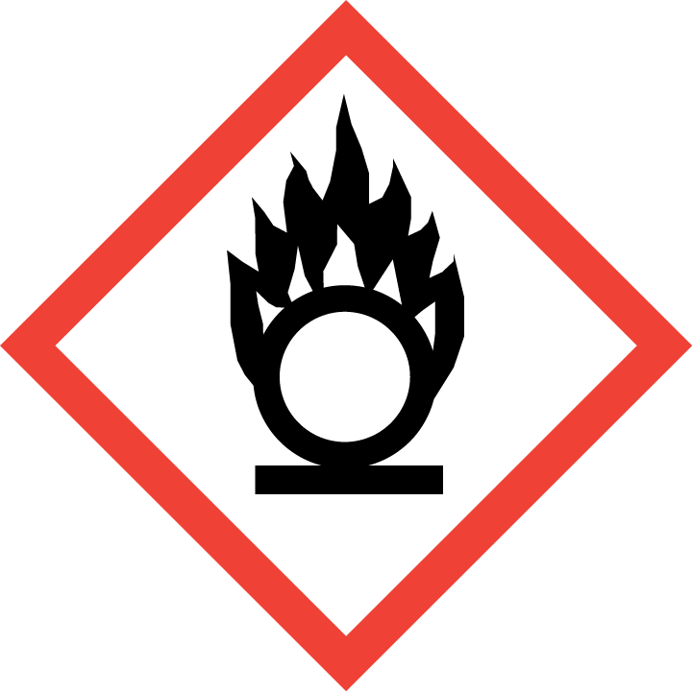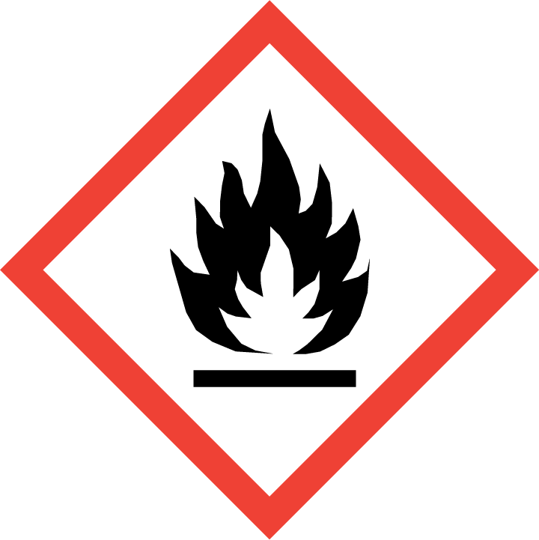
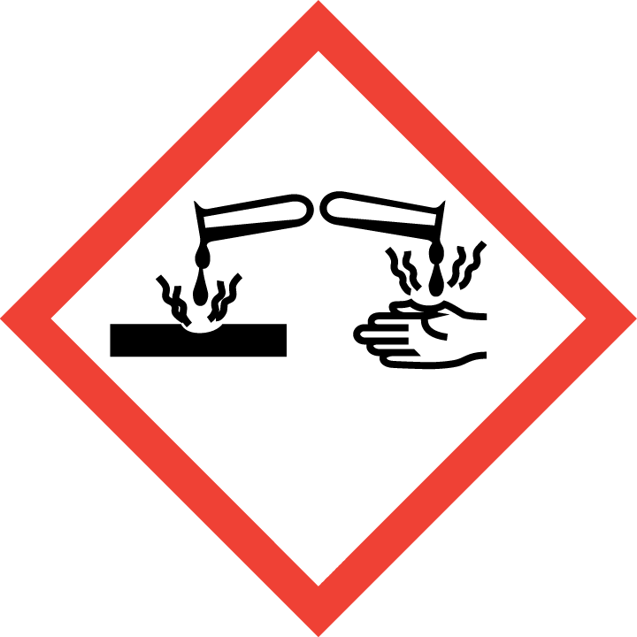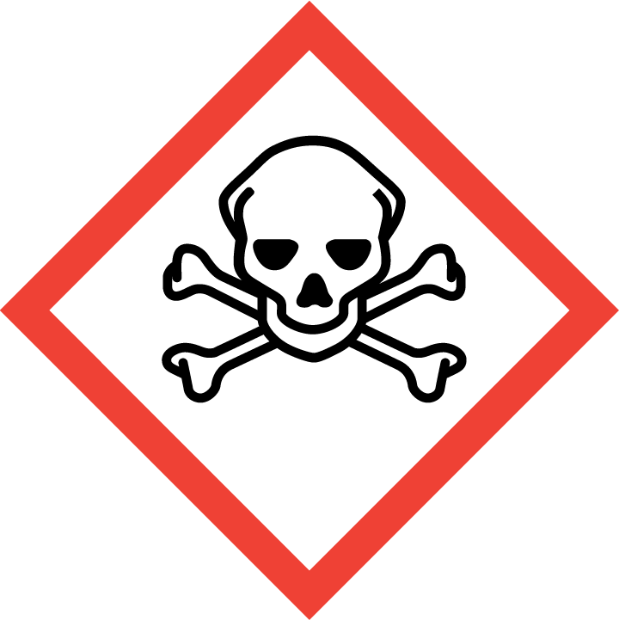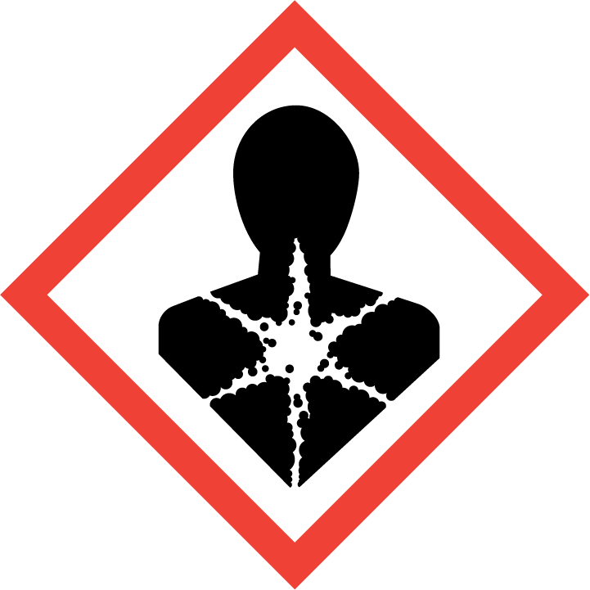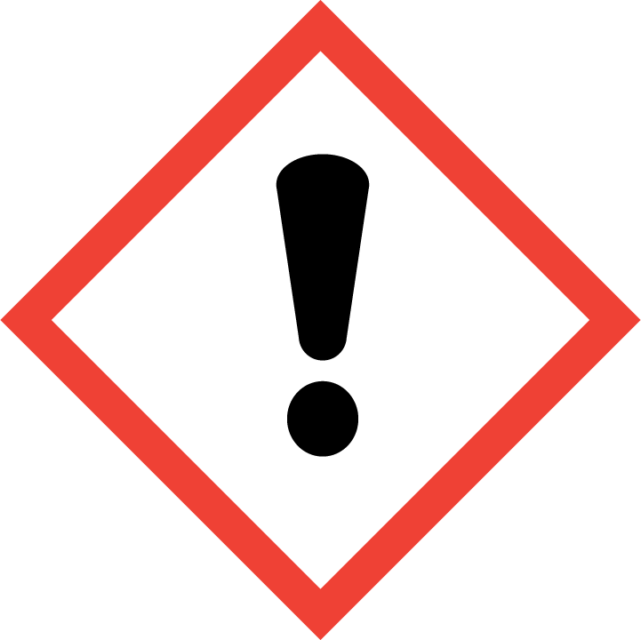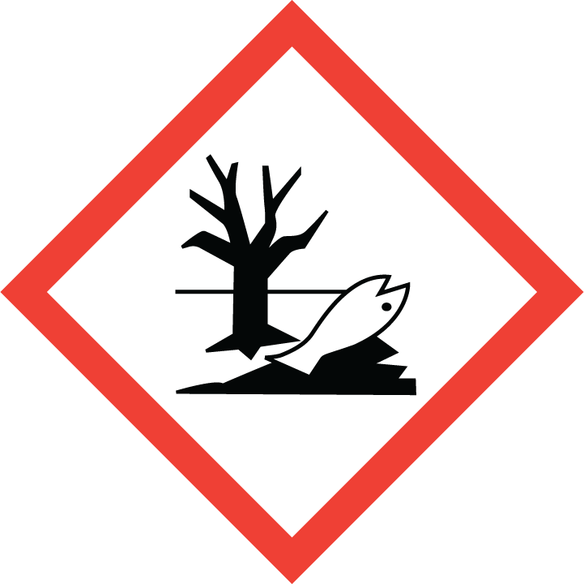

Excercises

Exercise 1a: Create a label for 2 mol/L NaOH

- Use e. g. Wikipedia to find the numerical identifier for sodium hydroxide.
- Calculate the mass percentage of NaOH in your solution (you need this to classify the solution).
- Go to ECHA CHEM to classify your solution.
  - Write the name in English or CAS-number for the substance.
  - Hit “Search”.
  - Scroll down and hit “Harmonized classifications”.
- Under “Classification” you will see the classification of the pure substance. Scroll down and use the “Specific Concentration limits” to classify your solution.
- You can find hazard pictogram, signal word and hazard statement in chapter 7 of Guidance on labelling and packaging in accordance with Regulation (EC) No 1272/2008.
- Precautionary statements:
You can find precautionary statements in chapter 7 of Guidance on labelling and packaging in accordance with Regulation (EC) No 1272/2008. There you will also find guidance on how to select precautionary statements. Normally, not more than six precautionary statements shall appear on the label, unless necessary to reflect the nature and the severity of the hazards. Any selection shall consider the hazard statements used, and the intended use or uses of the mixture. Precautionary statements with + between them, shall appear together.

Once you have selected precautionary statements for one hazard class, you can reuse them on other labels for that same hazard class.

Exercise 1b Create a label for 10 % hydrochloric acid, HCl(aq)

- Use Wikipedia to find the numerical identifier for hydrochloric acid.
- Go to ECHA CHEM to classify your solution.
  - Write the CAS-number for the substance.
  - Hit “Search”.
  - Scroll down and hit “Harmonized classifications”. Choose the classification for Hydrochloric acid… % (NOT hydrogen chloride which is HCl(g))
- Under “Classification” you will see the classification of the concentrated solution. Scroll down and use the “Specific Concentration limits” to classify your solution.
- Find the hazard pictogram, signal word and hazard statement for all the three hazard classes in chapter 7 of Guidance on labelling and packaging in accordance with Regulation (EC) No 1272/2008 ). All hazard statements resulting from the classification shall appear on the label.
- Precautionary statements:
Use the Guidance on labelling and packaging in accordance with Regulation (EC) No 1272/2008 and choose precautionary statements for each hazard class.

Exercise 2a: Create a label for 0,1 mol/L ZnCl₂

- Use Wikipedia to find the numerical identifier for zinc chloride.
- Go to ECHA CHEM to classify your solution.
  - Write the name or CAS-number for the substance.
  - Hit “Search”.
  - Scroll down and hit “Harmonized classifications”.
- Under “Classification” you will see the classification of the pure substance. Scroll down and use the “Specific Concentration limits” to classify your solution.
- For the hazard classes without specific concentration limits, you must use generic concentration limits to decide if and how the solution should be classified. All tables and equations referred to in the following part are also included in the PowerPoint presentation for the course.
  - (Skin corr 1B) Use table 3.2.3 in the CLP regulation.
  - (Aquatic acute 1) Go to section 12 of the safety data sheet. If the M-factor is already stated, use this. Otherwise, use the lowest LC₅₀ or EC₅₀ – value and the left side of table 4.1.3 in the CLP regulation to find the M-factor. Then use table and 4.1.1 in the CLP regulation to classify the solution.
  - (Aquatic chronic 1) Go to section 12 of the safety data sheet. If the M-factor is already stated, use this. Otherwise, use the lowest NOEC value and the right side of table 4.1.3 in the CLP regulation to find the M-factor. Then use table 4.1.2 to classify the solution.
  - (Acute tox. 4) Use the LD 50 /LC 50 where available (section 11 in SDS) or the conversion value from table 3.1.2 (that relates to the hazard category) in the CLP regulation to find the ATE of your substance. Then use the equation given in 3.1.3.6.1 in the CLP regulation (also shown below, where c = concentration in mass %) to calculate the ATE of the mixture. Finaly, use table 3.1.2 in the CLP regulation to find the hazard category of the mixture.
$${ATE}_{mix}=\frac{100*ATE}{c}$$
- Find the hazard pictogram, signal word and hazard statement for all relevant hazard classes in chapter 7 of Guidance on labelling and packaging in accordance with Regulation (EC) No 1272/2008).
- Precautionary statements:
For hazard classes where you have already found precautionary statements when making other labels – reuse them. Then use chapter 7 in the Guidance on labelling and packaging in accordance with Regulation (EC) No 1272/2008 and choose precautionary statements for the rest of the hazard classes.

Exercise 2b: Create a label for 2 mol/L ZnSO₄

