Risk assessment matrix
The risk assessment is according to the general procedure for risk assessment at UiO, and we are using a 5x5 risk assessment matrix.
Description of likelihood:
Likelihood |  | Description (This depends on what is being assessed, but these are examples):
1 | Rare | < 1x pr 50 yrs. or rarer
2 | Unlikely | < 1x per 10 yrs. or rarer
3 | Likely | < 1x per yr. or rarer
4 | Highly likely | 1x per month or more often
5 | Near certainty | Occurs weekly

Description of consequence:
 | Consequence: | Human: | Environment: | Equipment and economy: | Reputation:
1 | Minimal | Injury that requires first aid | Minimal damage and short restitution | Activity stop < 1 day | Little influence on credibility and respect.
2 | Minor | Injury that requires medical treatment | Minor damage and short restitution. | Activity stop < 1 week | Negative influence on credibility and respect.
3 | Major | Serious personal injury | Minor damage and long restitution. | Activity stop < i month | Reduced credibility and respect.
4 | Serious | Serious personal injury, possible invalidity. | Long term damage, long restitution. | Activity stop ½ - 1 year. | Severely reduced credibility and respect.
5 | Catastrophic | Death | Extremely long, not reversible damage. | Activity stop i more than 1 year. | Permanently reduced credibility and respect.

Propability | 5 | 1*5 | 2*5 | 3*5 | 4*5 | 5*5
Propability | 4 | 1*4 | 2*4 | 3*4 | 4*4 | 5*4
Propability | 3 | 1*3 | 2*3 | 3*3 | 4*3 | 5*3
Propability | 2 | 1*2 | 2*2 | 3*2 | 4*2 | 5*2
Propability | 1 | 1*1 | 2*1 | 3*1 | 4*1 | 5*1
Propability |  | 1 | 2 | 3 | 4 | 5
 | Consequence
Conclusion:
Colour |  | Description
Red | 10-25 | Unacceptable risk. Actions must be performed to reduce risk.
Yellow | 4-9 | Assessment area. The need for further actions to reduce riks should be assessed.
Green | 1-4 | Acceptable risk. Actions can be made.

Hazard symbols

GHS01 | 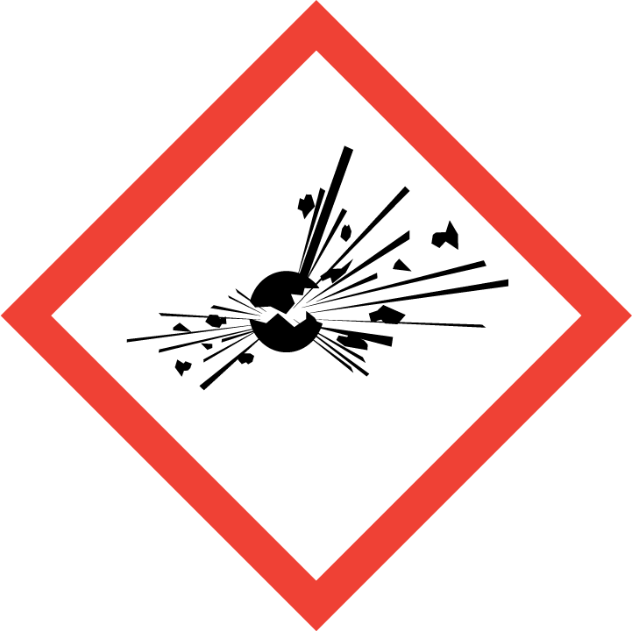
GHS02 | 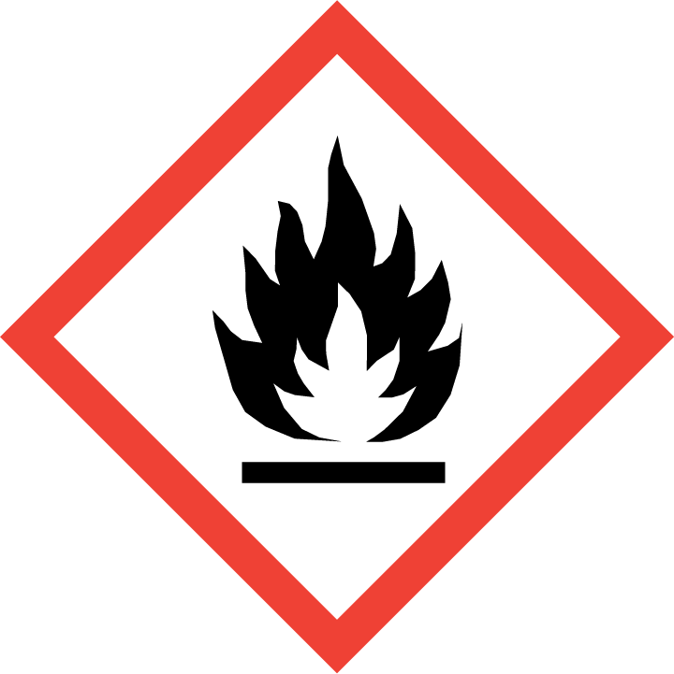
GHS03 | 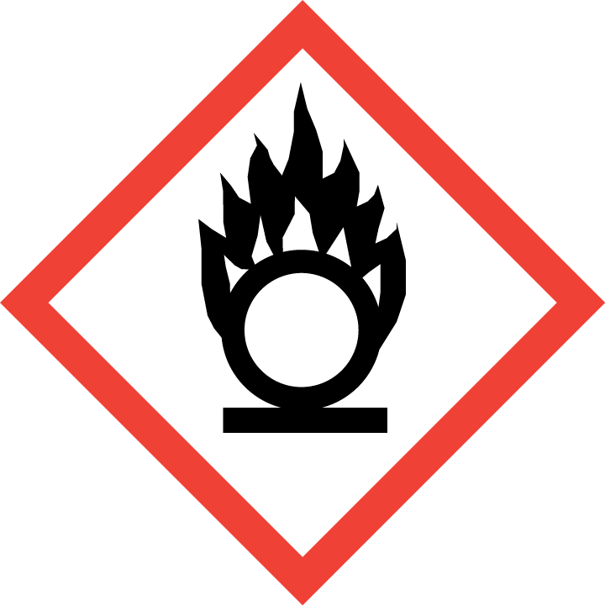
GHS04 | 
GHS05 | 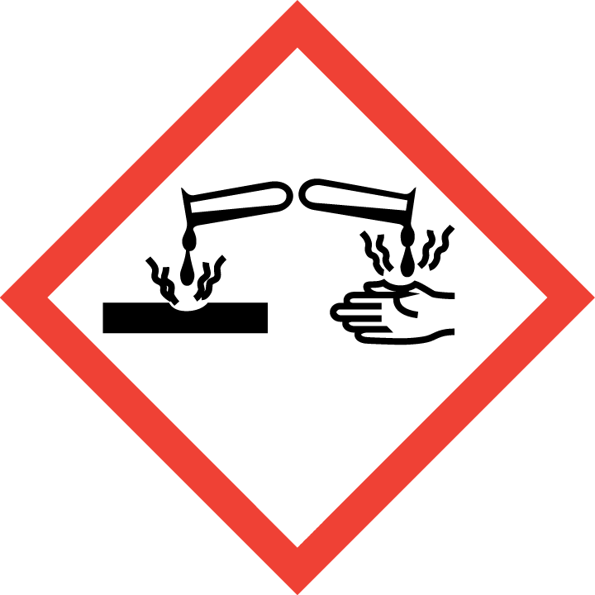
GHS06 | 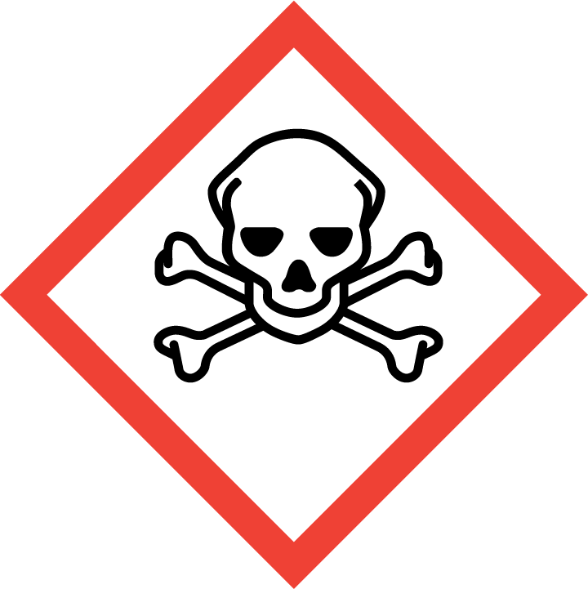
GHS07 | 
GHS08 | 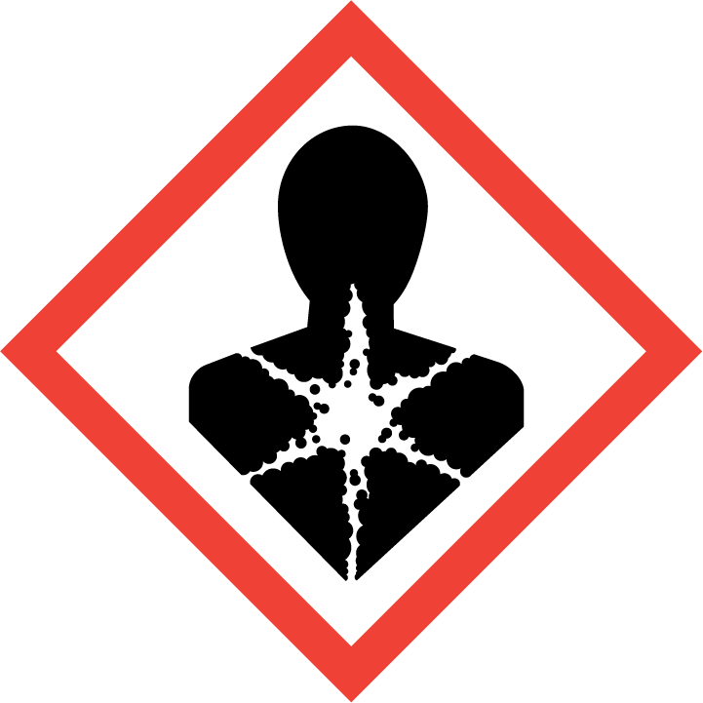
GHS09 | 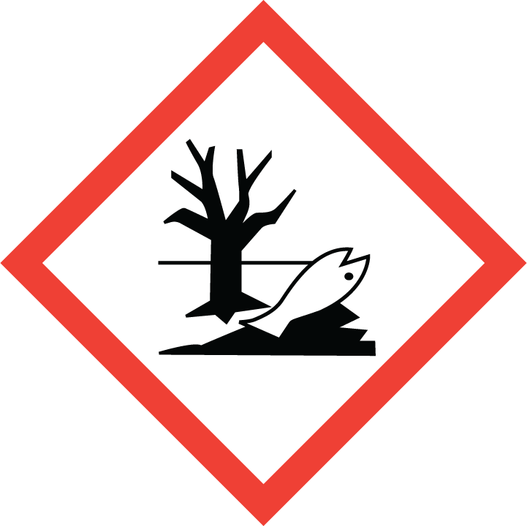

Safety Equipment
 |  |  | 
 |  |  | Fume hood
